Math Resource Center

Report Prepared By

Nina Bohrod
Sasha Verkhovtseva
Christie Sonnek

SIP Project Report: Feasibility Study and
Implementation of Math Resource Center

Project Members: Nina Bohrod (project leader), Sasha Verkhovtseva,
Christie Sonnek, Dave Roddy, and Barb Schewe


SIP Project Report: Feasibility Study and
Implementation of Math Resource Center

Introduction and Background
The need for a Math Resource Center on the campuses of Anoka-Ramsey Community College has long been apparent. Of the new students taking the placement test and enrolling in math classes at ARCC in fall 2006, 74% placed in developmental math classes (Institutional Research, email: February 13, 2007). There is evidence that math is the single greatest hurdle to successful progression in college. It should be noted that Mark Milliron, the keynote speaker for the January 2007 Development Days agenda, stressed this very point. “Data show that the top three ‘killer courses’ preventing students from advancing in college are developmental mathematics courses, with failure rates ranging from 35 to 42 percent. Six of the eight courses providing the most frequent roadblocks to advancement are math classes” (Noel-Levitz, 2006). Establishing a math resource center at the college is another step in developing an action strategy for supporting student retention and success.

The support required for students in all levels of math has expanded beyond the capabilities currently provided by the tutoring services of the Academic Support Center. As the enrollment of the college has increased, so has the diversity of the student body and the need for a comprehensive, dedicated facility for math support. This dedicated facility, which we will call the Math Resource Center (MRC) in this document, will provide not only tutoring services but a variety of resources for math students and instructors alike, including a library of textbooks and other reference materials, tools for math instruction both in and outside the classroom, and space for conducting workshops and for study groups to meet. The MRC will also provide access to the technology now integral to nearly all mathematics classes, from graphing calculators to websites for online courses. The staff of the MRC will provide support for use of these technologies for both students and faculty. The resources and support available in the center will reinforce math instruction in the classroom, with a designated math faculty member serving as coordinator between the center and the division and faculty members available for consultation in the center on a rotating basis. We envision the MRC as a center for math learning at all levels, bringing students, faculty, and support staff together in the commitment of ARCC to help our students become successful math learners and, hence, successful college students.

To achieve this end, the college approved the Strategic Initiatives Proposal (SIP) for determining the feasibility and overseeing implementation of an MRC on both campuses of Anoka-Ramsey Community College beginning July 2007 and concluding June 2008. The faculty involved in this project include Barb Schewe (now retired), Nina Bohrod, Christina Sonnek, and Sasha Verkhovtseva from the Coon Rapids campus and Dave Roddy from the Cambridge Campus. Nina Bohrod is the project leader. The goals of the project were outlined in the SIP as follows:
1) Through on-site visits, interviews, and data review, develop a “composite” picture of the functions, goals, and outcomes of successful math resource centers in certain MnSCU institutions and other institutions in the region.
2) Identify best practices for teaching and learning in math resource centers.
3) Develop a plan for creating and implementing a math resource center on both campuses of ARCC.
4) Establish a math resource center and goals for its first year of operation. 5) Develop schedule/position description for staffing center. 6) Adopt research agenda to track students who use the center.

This report summarizes the MRC project team’s findings and recommendations regarding implementation of an MRC on the Coon Rapids campus. (Please see the addendum for the report on recommendations for achieving the goals on the Cambridge campus).

Visit Reports
The MRC team visited five established Math Centers in the MnSCU system and one outside of the system. This section summarizes the team’s findings at each site visit. Complete reports for each site visit from each MRC team member are included in the appendix (including photos).

Site Visit -- University of Wisconsin Stout, July 10, 2007
Overview: Jean Foley is the director of the “Teaching and Learning Center” (TLC) at the University of Wisconsin Stout, and is also a faculty member. The TLC has two components: a classroom where all sections of developmental math are taught and an adjacent smaller room for tutoring. The TLC classroom is used for teaching Beginning Algebra and Intermediate algebra (no lower level math classes are taught at the university). In a typical class, a short lecture is followed by students completing exercises on MyMathLab software from Prentice-Hall publishers (UW – Stout is a laptop campus). Faculty all faculty use the same textbook. There is evidence of improvement of student success within those developmental courses but it is not clear if this translates into more success in the upper level math courses. The tutoring center is open for help outside of the classroom and is staffed by trained teaching assistants. Faculty also dedicate a part of their office hours to help in the tutoring center. The Stout team felt that having faculty members hold some office hours in the MRC was VERY helpful. It helped the students to realize that the faculty were approachable.

Some positive aspects of the UW – Stout set-up that the MRC team felt might work well in the ARCC MRC are as follows:
- Trained tutors.
- Faculty involvement.
- Friendly surroundings (faculty and tutor bios were a nice touch).
- Increased use and availability of software in classes and resource center.
- Funding through student fees?
- MRC website.
- Use of computers to monitor student progress and MRC use.

Some possible negative aspects:
- Requires laptop availability for all students.
- No computer sign-in.
- Small physical space.
- No space for group work or workshops.
- Lack of resources such as reference texts, worksheets, manipulatives, etc.
- Developmental-level exclusivity.
Site Visit – Century College, July 16, 2007
Overview: Mary LeClair is a College Lab Assistant 2 and also serves as director of the MRC. She has a staff of about eight to nine student tutors and uses about four tutors at a time during busy hours. The tutors are upper-level calculus students. The physical space consists of three rooms: one large room for individual study set up with tables and chairs, one smaller room for group study, and another smaller room for quiet study/testing. Five computers are available and are used mostly for students accessing online courses. The group study room is in high demand but is mostly claimed by the calculus students. Faculty offices are just off the MRC. The Century College MRC serves all levels of math students. The staff has done well at including both developmental and college-level students. Mary stressed this facility is really a study center and not a tutoring center. Tutors spend only five to ten minutes with a student. If a student requires more in depth tutoring they are sent to the Tutoring Center. Many resources are available including videos from textbooks, solutions manuals, reference books, calculators, and math skill sheets.

Overall, Mary feels that the system at Century works well. However, she would like to see more faculty involvement in the MRC, perhaps having instructors hold some office hours there (currently instructors are not required to use the MRC or spend time there). She feels the MRC would benefit also from having more computers available and installing a computerized sign-in system. Mary feels at times that there is often too much demand on her time with having to combine tutoring duties with administrative responsibilities. Mary stresses that diversity is important among the tutoring staff. She also recommends that there should be at least one tutor who can do statistics and one familiar with math required for health care professionals, such as medical dosages. She highly recommends having an “open” and non-intimidating feel to the MRC (such as having windows into the MRC so that students can see the space before they walk in). She also suggested that, since students relate well to other students, it’s helpful to have the student-tutors go to classes to advertise the MRC.

Some positive aspects of the Century set-up that the MRC team felt might work well in the ARCC MRC are as follows:
- Flexible and large space with separate work-areas.
- Open and inviting space.
- Comprehensive resources available.
- Diverse and trained tutors.
- Supports all levels.
- Computers and software available.
- Adjacent to faculty offices.

Some possible negative aspects:
- One position for both tutoring and administrative responsibilities.
- Low faculty involvement.
- Inadequate computer availability.
- No computer sign-in.
- Not enough direct focus on developmental students.

Site Visit – North Hennepin Community College, July 17, 2007
Overview: Dale Bradtke is the MRC supervisor. He is a CLA-2 but has “director” responsibilities as well. The MRC consists of a small tutoring area and a computer lab which is also sometimes used for testing. The space is furnished comfortably with a couch and coffee table as well as tables and chairs. The MRC is adjacent to a larger space which accommodates the Academic Support Center (both are located in the library). The MRC serves all levels but there is a program (“First Year Experience”) that targets developmental students. Students get questions answered in the MRC. They are referred to the ASC for more extensive tutoring. (As Joe Crowe of the ASC said, “ASC is sit down, the MRC is fast food”). Student tutors are available in the ASC but Dale is by himself in the MRC. He answers 400 to 500 questions a day (“there is pretty much always a line for help”).

Dale bemoans the lack of faculty involvement and support for the MRC. Also on his wish list were student-tutors, more money, and more space. Dale has extensive experience and degrees in math and science but he seems overextended in his responsibilities. There is a part-time CLA-2 in the evenings but there is no back-up for the MRC when Dale is unavailable. Both Dale and Joe hold workshops as needed.

Some positive aspects of the North-Hennepin set-up that the MRC team felt might work well in the ARCC MRC are as follows:
  - CLA-2 staff member with extensive experience and training.
- Open and inviting space.
- Comprehensive resources available.
- Workshops based on student needs (test-taking, math anxiety, etc).
- Supports all levels.
- Computer sign-in in ASC.
- Program targeting developmental students.
- Separate video area.

Some possible negative aspects:
- One position for both tutoring and administrative responsibilities.
- Low faculty involvement.
- No student tutors.
- Inadequate budget.
- Small space.

Site Visit – Inver Hills Community College, July 31, 2007
Overview: Jan Kamp is the Math Center Coordinator and is also a faculty member. She receives four credits per semester as coordinator. The Math Center is located on the top floor of the library (actual library facility is downstairs), in a large, open area adjacent to Peer Tutoring, surrounded by Faculty Offices. There is a separate computer area with 16 monitors and extensive math software available, including tutoring packages. Some rooms are available in the library for study groups but they are not very inviting (sparse and cold) so they don’t get much use. The main purpose of the Math Center is to answer student questions on assigned material and more extensive tutoring is conducted in the Peer Tutoring area. Jan supervises two lab assistants. There are no students tutors available on a regular basis but peer tutors from the Peer Tutoring Center occasionally help out. The Math Center serves all levels.

Jan estimates that 50-60% of the students served are developmental. This center has more success than most in attracting developmental students. One component of that success may be the high level of faculty involvement in this center. The budget allows for up to 12 credits per semester of faculty time spent in the Math Center. In addition, each instructor fills out forms for the Math Center staff giving guidelines for their classes and puts information about the center in the syllabus. Some instructors provide extra credit to their students who use the center or may assign computer work that students can complete in the center. Overall, Jan is satisfied with the level of faculty involvement and with the operation of the math center in general. The computer-sign in system works particularly well as Jan is able to obtain detailed statistics on student usage. Her wish list includes “differentiated areas” for group study, quiet areas, etc., and a separate entrance for the center (noise levels and other distractions are sometimes a problem due to the open design of the area).

Some positive aspects of the Inver Hills set-up that the MRC team felt might work well in the ARCC MRC are as follows:
- High level of faculty involvement.
- Success in attracting developmental students.
- Large, inviting space.
- Comprehensive resources available to both students and instructors.
- Large computer area with math software available.
- Location adjacent to faculty offices and Peer Tutoring Center.
- Computer sign-in.
- Supports all levels.

Some possible negative aspects:
- No separate entrance (noisy and distracting).
- Insufficient group study and quiet areas.
- No student tutors.

Site Visit – Normandale Community College, August 13, 2007
Overview: The operation of the Math Resource Center at Normandale is somewhat like that at UW – Stout. Developmental classes only (beginning and intermediate algebra) are conducted here. Unlike the system at Stout, however, there is no lecture and students work at their own pace on computer tutorial systems (MyMathLab and MathXL). There are benchmarks as to when students must complete chapter tests and if a student does not make this benchmark they often drop out of the class. The physical space is large with about 29 computers available and a separate testing room that can hold 40-45 students. Three full-time and one part-time lab assistants are available. There is a separate tutoring center that serves upper-level math students (as well as other subject areas). Student tutors and volunteer tutors from the community are available. Faculty also are involved in the tutoring center. Some faculty hold office hours there and some volunteer. Communication between faculty and the tutoring center is a priority.

Unfortunately, the success rate with this self-paced system for developmental students is low (between 40-50%). The tutoring center seems to have more success with greater faculty involvement. The tutoring center staff would like to have more room (there are often people waiting) but there is a separate group study room.

Some positive aspects of the Normandale set-up that the MRC team felt might work well in the ARCC MRC are as follows:
- Large and inviting physical space in MRC.
- Computer availability.
- Faculty involvement in tutoring center.
- Community involvement in tutoring center (provides extra tutoring service and also helps create a link between the community and the college).
- Separate group study room in tutoring center.

Some possible negative aspects:
- Low success rate for developmental students in MRC.
- Insufficient space in tutoring center.
- Differentiated facilities for developmental and upper level students.

Site Visit – St. Cloud State University, June 26, 2007
The Math Skills Center serves development students only (beginning and intermediate algebra). Students have three hours of lecture per week and are expected to spend up to two hours per week using a computer homework system (Math XL) in the Math Skills Center. The center has 34 computers and a few tables for small study groups. Faculty offices are adjacent. The center is staffed by one tenure track, five fixed term, and three adjunct faculty, resulting in a high level of faculty involvement. There are 15-20 peer tutors as well. St. Cloud also has separate computer lab for upper-level courses and a Math Resource Center with resources available. The teaching staff of the Math Skills Center expressed a desire to have more space for study groups.

Some positive aspects of the St. Cloud set-up that the MRC team felt might work well in the ARCC MRC are as follows:
- Faculty involvement
- Program targeting developmental students.
- Large computer area with math software available.
- Student tutors.

Some possible negative aspects:
- Insufficient group study areas.
- Developmental-level exclusivity.
- Differentiated facilities for developmental and upper level students.

Recommendations
Based on observations and interviews during site visits, general research, and first-hand knowledge of the particular needs of math students at ARCC, the MRC team has identified the main components required for a successful MRC at ARCC as follows (see the “Details” sections for more specifics regarding each proposed component):

1. Active faculty involvement.
Among math center staff that the MRC team interviewed, the level of faculty involvement was cited as the number one key to the successful operation of the center. Faculty involvement relates directly to the overall success in attracting students to the center. As one math center staff member stated, “Getting students through the door is the toughest.” Faculty involvement also helps the math center staff make important connections between the classroom and the center, reinforcing concepts taught in the classroom and communicating with the faculty as to the specific topics in which students may be deficient. Math center staff and faculty can also work together to determine the appropriate resources needed in the math center and to develop workshops as needed. Most important, involvement of the math faculty in the math resource center communicates to students that learning math is a process that requires intensive daily practice, and may involve individualized instruction, group work, and use of software and other resources that are available outside of the classroom.

To ensure this connection is maintained at the Anoka-Ramsey MRC, the MRC team proposes that one full-time math faculty member serve as the coordinator of the Math Resource Center, working with the math center staff as needed and acting as liaison between the center and the math department. The team also recommends that math faculty participate in staffing the math center on a regular basis, working with individual students and groups. Additionally, peer tutors from the MRC should be available to assist instructors in developmental classes, allowing for more individualized instruction in the classroom and further promoting the Math Resource Center among students.

2. Serve all levels but with specific programs targeting developmental students.
Among the math centers the MRC team visited, some focused on developmental students exclusively with varying levels of success. The MRC team feels that the most successful math center design for Anoka-Ramsey Community College is one that serves all levels of math students.

The rationale for this approach is three-fold. First, students at the developmental math level may have had few successes in math courses in the past or may have been told they are simply “not good in math”. Such experiences may lead these students to suffer from feelings of inferiority among their peers and from math anxiety. Math anxiety often leads to a cycle of math avoidance: negative math experiences lead to math avoidance which leads to poor mathematics preparation which leads to poor math performance which generates more negative experiences with math. (Preis and Biggs, (2001) Can Instructors Help Learners Overcome Math Anxiety? ATEA Journal, Vol 28(4), 6-10, Apr/May). Providing a math center for this group of students only may reinforce the sense that somehow they are “different” than other math students and are being targeted for remedial intervention. The risk is that such a Math Center will bear the stigma as a place for only those with few math skills and will be underutilized as a result. Several of the math center directors interviewed stated that attracting developmental students to the center was a particular difficulty. At the 2008 ITeach Conference on Realizing Student Potential, members of the MRC team attended a session entitled “Mathematics: Enhanced Learning Environments”. The moderators of the session, Margaret Klindworth and Rupa Mitra, from Minnesota State University – Moorhead, revealed that the student usage of their developmental-only math center was quite low and student success and retention rates were unsatisfactory. Faculty in general stated that strategies such as requiring developmental students to use the center or penalizing them for not using it were ineffective. The MRC team feels that the most effective method for encouraging use of the math center among developmental students is to lead by example. In other words, in a math center open to students of all math abilities, developmental students will follow the example of upper level students by first, entering the facility, and second, utilizing all of its resources. Developmental students will observe, for example, college algebra students in tutoring sessions, trigonometry students using the calculators and computer software, calculus students forming study groups, and even faculty discussing the latest conference proceedings. Developmental students will discover, without coercion, that learning math is an on-going process, that there are many different methods of teaching and learning, and that part of the learning process is to use the available resources to find what works best for them. Even upper-level students will benefit by the presence of lower-level students. Just an occasional opportunity to explain a concept to a student in a lower-level course will help upper-level students refresh their basic math skills and practice their teaching skills.

Second, the current Academic Support Center is insufficient to meet the needs of upper-level students. There are few tutors with the skill levels available to tutor upper-level students. Often, there are no tutors available for statistics courses. Upper level students need more access to computers and mathematical software such as “Converge”, “Derive”, and “Mathematica” and need a trained professional to assist them in using such software. The current Academic Support Center has no separate facilities for study groups to meet and no formal procedures for organizing study groups. Upper-level students require access to resources such as reference texts, solution manuals, and information on math programs in four-year colleges and on careers on mathematics.

Third, all of the developmental-only programs the MRC team observed required that faculty use identical methods for instruction and a common text. These programs have had mixed success in improving success and retention rates. This “one-size-fits-all” approach can be problematic. Students have different learning styles and may benefit from using different textbooks. Instructors can be more effective when they have the academic freedom to choose an instruction method and text that aligns with their teaching style. Instructors may also use different methods of instruction within a class to reach students with varying learning styles. The MRC should provide the resources to support a variety of teaching and learning styles such as manipulatives, videos, skill sheets, and tutorial software.

For the above reasons, the MRC team recommends that the MRC at ARCC serve all levels of math students, with programs within the center that target the particular needs of developmental students. Such programs could include intense tutorial sessions on specific topics, classes that meet in the math center on occasion to instruct students in the use of tutorial software, peer tutors assisting instructors in developmental classes, workshops targeting developmental students, or even “rotating display” areas in the center that focus on “Women in Mathematics” or “First-Generation College Students”.

In short, in serving students of all levels of mathematical ability, the MRC team feels that the Math Resource Center at Anoka-Ramsey will best follow the motto of the National Association for Developmental Education in, “Helping under-prepared students prepare, prepared students advance, and advanced students excel.”

3. Trained and experienced staff.
As described above, the MRC team recommends that one full-time math faculty member should serve as the coordinator of the MRC, working with the math center staff as needed and acting as liaison between the center and the math department. The daily operation of the MRC will be overseen by a full-time College Lab Assistant (CLA-2). This position will require tutoring ability in developmental and upper-level math (preferably statistics as well). Therefore, a bachelor’s degree in math is strongly recommended as a requirement for this position. The first-time hire for this position will necessarily be involved at all levels in the initial stages of developing and implementing the MRC. He/she should therefore have extensive knowledge in tutoring methods and have the communication skills necessary to work with the math faculty to ensure that the MRC reinforces classroom practices. The MRC team also recommends a part-time CLA-2 be available in the evenings for night students. Additional qualifications and responsibilities for the CLA’s are outlined below in the “Details” section.

The CLA’s will oversee the student (or peer) tutors. Peer tutors should be math students recommended by math faculty. Peer tutors should be comprised of a group that reflects the diversity of the student body, including men, women, native English speakers, and English language learners. Peer tutors should be available for all math courses, including statistics, liberal arts math, and math for health sciences.

4. Accommodate students’ needs.
Several of the facilities the MRC team visited had a “two-pronged” approach to tutoring. The math center area was available for students to ask questions and receive help on homework assignments while more intensive tutoring took place in the Academic Support Center. This model works well if the two centers are in physical proximity and if the center directors collaborate extensively. However, the MRC team recommends that all math tutoring take place in the MRC to avoid confusion among students and to provide the MRC staff and math faculty with comprehensive and efficient feedback regarding students’ progress. The Anoka-Ramsey MRC will have both “take-out” and “sit-down” styles of tutoring which may take place in distinct areas of the center. MRC staff will keep records of students’ usage under these two categories.

Students at Anoka-Ramsey typically have many responsibilities outside of school. Students with jobs or families often have limited opportunity to be at school, with early-morning or evening classes their only options. To accommodate these students and since most math classes at the college are held between the hours of 8 a.m. and 9:10 p.m., the MRC team recommends the following schedule for the MRC: 7:30 a.m. to 8 p.m. Monday--Thursday and 7:30 a.m. to 2 p.m. Friday. This schedule aligns with that of the college Academic Support Center and reflects usage hours at other MNSCU math centers. The schedule for the Anoka-Ramsey MRC may be adjusted in the future as usage data becomes available.

5. Ample, flexible, and inviting physical space.
A flexible and inviting physical space is a primary characteristic of a successful math center. The MRC team recommends that the Anoka-Ramsey facility have four distinct areas: an open study/tutor area, a group study area, a computer area, and a quiet-study/test-taking area. The group study and test-taking area need to be separate rooms for noise control but the study/tutor and computer areas can share a room. Because of the importance of faculty involvement in the success of the MRC, the center should be located near math faculty offices.

To overcome students’ initial anxiety in seeking help in math, every attempt should be made to make the space comfortable and inviting. Windows from the hallway into the MRC will allow reluctant students to observe that the center is “non-threatening”. A lounging area with a couch, upholstered chairs and a coffee table will suggest that studying math need not be stressful. A computer sign-in at the entrance should be convenient and simple to use. It should be made clear to the students that the computer sign-in system is being used to track overall usage only and will not maintain records on individual usage or store personal data. Signage for different areas of the center and for available tutors should be clear and direct. Biographies should be posted describing the background and interests of each MRC staff member, math faculty member, and peer tutor. Furniture in the tutoring area should consist of modular wheeled tables and chairs so that students can easily arrange themselves individually or as a group depending on their studying needs. The CLA should have a clearly defined space with a desk, shelves, and cabinets as needed, along with a locked cabinet to store materials that can be “checked-out”: solutions manuals, textbooks, calculators, etc.

The computer area should be large enough to accommodate the increasing requirement for computer use in math courses. Ideally, there should be enough computer terminals to allow instructors to hold occasional classes in the computer area and provide direct instruction on using mathematical software to students. Alternatively, existing computer lab areas on campus could be expanded. (Since math classes have up to 45 students there is a need for a computer lab on the Coon Rapids campus with at least 45 terminals).

The quiet study/test-taking area should be large enough to accommodate groups of students from online math courses coming to campus for proctored exams (15-20 students). It is increasingly becoming a problem to find space to accommodate these students.

Additional requirements for the physical space of the MRC are outlined below in the “Details” section.

6. Comprehensive resources.
The MRC should provide resources for use by both students and faculty including textbooks, solution manuals, software, manipulatives, skill sheets, videos, and reference materials.

With the rising costs of college many students have difficulty paying tuition and sometimes forego even the required materials for a course. To help retain some of these students, the MRC team recommends implementation of “check out” programs for certain materials commonly required for completion of math courses. The “check-out” materials will include current textbooks, graphing calculators, and even access codes required for online homework systems used in many classes. If possible, the “check-out” materials could be made available to students on a need-based system.

Software used in classrooms or for assignments as well as a variety of tutorial programs should be available on all of the computers in the MRC.

More specifics regarding recommended resources for the MRC are outlined below in the “Details” section.

Measuring Success
It is difficult to measure student pass and retention rates based on math center usage and little data is currently available. A number of factors make this type of data difficult to obtain. Foremost is the inability to isolate the cause and effect related to student success. A blind study, in which a random group of students would be selected to use the center and a random “control” group would not use it, is obviously impractical. Comparing student success rates after the math center is in place to that of previous years may have some implications but, again, cause and effect may be unclear. The rates should be compared over a number of years for more reliable results.

Several of the math centers the MRC team visited track student usage data such as class, instructor, and type of question asked. This data gathering is facilitated by the use of a computer sign-in system. This information is valuable to instructors and math center staff in tailoring courses and center resources based on student needs.

The MRC team recommends that the institutional researchers at the college participate in determining and interpreting MRC usage data. This participation should take place from the initial stages of the MRC implementation to several years into its existence.

Anecdotal evidence of improved student achievement is, however, readily available. In a letter to the CLA of the math center at Century College, one student proclaimed, “We have been aware of the exponential benefits given by [the CLA] and the tutors who are the essential backbone for success in mathematics.”

Conclusion
The MRC team recommends establishment of a Math Resource Center that will help every student taking a math course at ARCC. The primary components required for achieving this goal are a functional and inviting physical space, comprehensive resources, trained and dedicated staff, and involvement of the math faculty. The MRC team envisions the MRC as a place where students and faculty will come together to extend classroom interactions, where struggling students will find help and encouragement, and where ideas and knowledge will be exchanged. The hope is that the MRC will become a math “hang-out”, where students and faculty want to go, rather than are compelled to go, to explore all things mathematical.

This hope may be somewhat idealistic but any achievement towards this end will better serve our math students. Our students need and deserve a centralized location where they can get their questions answered, learn new technologies, sit and study in a quiet comfortable place, and work together in study-groups. The MRC will serve all of these purposes by offering continuous support to our students through every means possible.

It may not be feasible to institute all of the MRC team’s recommendations immediately and implementation may have to occur in stages. However, any initial program should include planning for continued expansion until the MRC meets the stated goals and fulfills the promise of this institution to:

- Excel in teaching and learning (SIP Objective I)
- Apply innovative strategies to enhance teaching and learning.
- Increase student success as measured by student learning, achievement of student goals, and student contributions to the community.
- Excel in student development and support services (SIP Objective II)
- Be the college of choice for faculty and staff (SIP Objective III)

Details
Faculty Involvement
- One full-time math faculty member will serve as the coordinator of the MRC working with the math center staff as needed and acting as liaison between the center and the math department (3 credits release time/semester)
- Math faculty will participate in staffing the math center on a regular basis, working with individual students and groups of students
- Faculty will use office hours or credit release time to work in MRC (1 office hour/week)
- Faculty will include information about the MRC in syllabi

General Operation
- Hours: 7:30 am – 8 pm Monday-Thursday, 7:30 am – 2 pm Friday.

The MRC will provide students with a place to
- study and work on their math homework
- get their questions answered quickly by student tutors and staff
- meet in groups to work on assignments and discuss course material
- use computers, log on to math software, and get help using math software
- meet with faculty in order to extend classroom learning
- attend workshops on topics that many students struggle with, such as math anxiety, arithmetic skills, fractions, test-taking and calculator use
- study in a quiet environment

Programs Targeting Developmental Students
- Math Center orientation for new students
- Required attendance at workshop prior to taking Accuplacer
- Workshops on calculator use, overcoming math anxiety, test-taking skills and strategies, and the most difficult topics such as fractions, factoring, geometry, etc.
- Designated tutoring sessions for developmental only
- Targeted instruction on use of tutorial software
- Peer tutors available to assist instructors in the class room
- Other programs at discretion of individual instructors
- Extra credit for using math center
- Communication between the students who take upper-level math courses and the developmental students

Staff
- Coordinator
- One full-time math faculty member will act as liaison between the MRC and the math department
- 3 credits release time per semester
- Works with CLA to determine appropriate workshops, tutor training, faculty training, resources, software, etc. for most effective use of MRC and updates materials as required each semester
- Ensures MRC reinforces classrooms practices
- Promotes use of MRC among students and faculty
- Coordinates schedule of faculty holding office hours in MRC
- Reports to division on issues concerning MRC

- Full-time CLA-2
- Qualifications: Post-secondary coursework in Mathematics sufficient to provide technical lab services for students, faculty, and staff OR 6 months of teaching/tutoring experience in Mathematics at the high school level or above.
- Preferred Qualifications: Bachelors in Math or Math Education with teaching experience; some knowledge of statistics; experience working with persons of diverse backgrounds.
- Responsibilities: tutor students, conduct training sessions and supervise student tutors, arrange tutor schedules, participate with hiring student tutors, develop and conduct student workshops, act as liaison between math faculty and the MRC, evaluate and implement software, assist students with software use, organize study groups, initiate and coordinate classroom visits, maintain and update MRC website.

- Part-time CLA
- Qualifications: Post-secondary coursework in Mathematics sufficient to provide technical lab services for students, faculty, and staff OR 6 months of teaching/tutoring experience in Mathematics at the high school level or above.
- Responsibilities: tutor students, supervise student tutors, and participate with hiring student tutors, conduct student workshops.

- Peer Tutors
- Students who have completed coursework in mathematics at ARCC and are recommended by faculty
- 8-10 per semester, with 3-5 working at any given time (this will be fine-tuned as needs arise).
- Available for all levels and all math courses including statistics, math for health sciences, liberal arts math
- Diverse group reflective of diverse student body, including men, women, Native English speakers, ESL students

- Volunteer Tutors
- Volunteer tutors from outside ARCC community (provides extra tutoring service and also helps create a link between the community and the college).

- Math Faculty
- Math faculty can use office hours or release time to work in MRC .

Physical Space
- Located near faculty offices
- Windows from hallway into center
- Four distinct areas including:
  - Study/tutor area (main area with the inviting, friendly space)
  - Computer area
  - Group study area (separate room for noise control) large enough to accommodate 8-10 students
  - Quiet-study/test-taking area (separate room for noise control) large enough to accommodate 15-20 students
- Computer sign-in with “card swiper” at entrance
- Suggestion box
- Faculty/tutor biographies and photos posted
- Rotating display relevant to students in math such as “Women in Math”, “Careers in Math”, etc.
- Handicapped accessible

- Furniture
- Wheeled modular tables/chairs so that students can arrange themselves individually or as a group depending on what the situation calls for (see the drawing below)
- Computer desks/workstations
- Couch/comfy chair(s), coffee table to create a comfortable and inviting feel within the MRC
- Filing cabinets
- Cabinets that can be locked for staff to store solution manuals, textbooks, calculators and other items to be “checked-out”.
- Bookshelves
- Skills sheet organizer shelf
- Desk and chair for CLA/Director

Resources
- Technology: Hardware
- 20 computer terminals (expand to 45 in no computer lab available for seating classes)
- 1-2 TV/VCR/DVD combos for videos
- Computer sign-in system with “card swiper” to track student usage
- Projector for use in workshops
- Document cameras available for student and faculty use
- Smart boards

- Technology: Software
- Derive
- Converge
- Mathematica
- MiniTab or other statistical software
- MyMathLab and other online homework programs (access codes)
- Tutorial software
- Microsoft office and other software included on all campus computers
- Other software, as needed

- Technology: Calculators
- 8 calculators for use in the MRC (five TI-84s and three TI-89s)
- 25 calculators for the “Calculator Checkout Program” (twenty TI-84s and five TI-89s)
- Training of MRC tutors on calculators
- Calculator workshops

- Reference Materials
- Textbooks currently used in courses for use in the MRC
- Calculator manuals
- Solution manuals
- Information on math programs in four-year colleges
- Information on careers in math
- Other reference books for use by students and faculty

- Manipulatives
- Montessori learning materials for developmental students
- Materials for teaching fractions including measuring cups, water table, fraction circles, etc.
- Materials for teaching geometry including geometric figures in two and three-dimensions

- Miscellaneous
- Whiteboards
- Skill sheets
- Decorations (pictures, posters, etc)
- Carpet/rug
- Graph paper including polar coordinate systems
- Scrap paper
- Tutor training materials
- Faculty training materials
- Math Resource Center website with updated information

Cost Estimates
- Initial budget
- Computers:
Quantity: 20 Student Stations
PC & LCD $30,000
Wiring $5,000
Switch/Panel/Cables/Fiber $5,000
UPS $1,500
Patch Cables, Power Strips, misc. $500
(source: Tim Zlondo)
- Calculators
25 TI-84’s $125/each
8 TI-89’s $175/each
IT-Presenter $275
- Other technology:
1-2 TV/VCR/DVD combos for videos $750/each
Computer sign-in system with “card swiper” to track student usage
Projector for use in workshops $1500
Document cameras available for student and faculty use $2200/each
Smart boards $6000
- Furniture
Wheeled modular tables/chairs $20,000
Computer desks/workstations $16,000
Couch/comfy chair(s), coffee table $2500
Filing cabinets $2400
Bookshelves $775
Skills sheet organizer shelf $4000
Desk and chair for CLA/Director $2500
- Books
Textbooks $5000 (may be reduced by requesting courtesy copies from
publishers)
Textbook solution manuals $0 (come with text books)
Calculator manuals (come with text books) $0 (come with text books)
Reference texts $1000
Other $500
- Manipulatives
Mathematical tools used in Montessori instruction
Geometry kits (already have these) $0
Fraction circles
Other
- Software (25 Licenses)
Derive $0 (Site License)
Converge $1500
Mathematica $0 (Site License)
MiniTab or other statistical software $1875
MyMathLab and other online homework programs (access codes)
Tutorial software
Microsoft office and other software included on all campus computers
$0 (Site License)
Other software, as needed
- Yearly operating budget
- Salaries
Math faculty coordinator 3 credits/semester
CLA (full-time) $50,000 with benefits
CLA (part-time) $20,000 with benefits
Peer tutors Work study/Institutional funds
- Update resources
- Incidentals $800-$1000
Appendixes
A Sip Proposal and Budget – page 21
B Timeline – page 26
C Cambridge MRC Summary – page 27
D Reports on Century College MRC – page 32
E Reports on Inver Hills Community College MRC – page 40
F Reports on North Hennepin Community College MRC – page 49
G Reports on Normandale Community College MRC – page 58
H Reports on University of Wisconsin - Stout MRC – page 65
STRATEGIC INITIATIVES PROPOSAL APPLICATION - FY08
Proposal Title: | Feasability Study and Implementation of Math Resource Center
Submitted by: | (Include partner names from each campus and outside community.)
Coon Rapids:Barbara Schewe, Sasha Verkhovtseva, Nina Bohrod, Christina Sonnek Cambridge: Dave Roddy
Project Contact Name: |  | Barbara Schewe or Nina Bohrod |  |  |  | Phone: |  | 1122 (Barb) or 1344 (Nina)
Date that this proposal was discussed with Dean/Supervisor during department/division meeting: |  |  |  |  |  |  |  | 2/5/2007
Dean/Supervisor signature approval:
Briefly describe your proposal:
Investigating the feasibility of a math resource center, developing a plan for its implementation, and overseeing implentation on both campuses of the college. Implemention includes setting up location and equipment, developing budgets, delineating personnel responsibilities, establishing first-year goals, aligning with Developmental Education Task Force and IPESL grant activities.
Identify and explain how your proposal supports one of the following Strategic Objectives:
This project supports the college’s initiative to increase access and retention for students. Establishing a math resource center, based on qualitative and quantitative research, promotes the objectives of the college to “excel in teaching and learning… [with a] formal plan for …assessment of student learning in development education…”
Check off |  | Objective I. B. Identify and encourage best practices for classroom implementation.
Objective(s): | X | Objective II. ARCC will excel in student development and support services.
 |  | Objective V. ARCC will enhance existing career and transfer programs and establish new areas of study
 |  | that respond to the needs of the community, employers, and the state.
Identify the project's objectives:
1) Through on-site visits, interviews, and data review, develop a “composite” picture of the functions, goals, and outcomes of successful math resource centers in certain MnSCU and other institutions in the region.
2) Identify best practices for teaching and learning in math resource centers.
3) Develop a plan for creating and implementing a math resource center on both campuses of ARCC. *(Please see addendum for specifics regarding implementation on Cambridge campus.)
4) Establish a math resource center and goals for its first year of operation. 5) Develop schedule/position description for staffing center. 6) Adopt research agenda to track students who use the center.
What resources (budget, staff, etc.) are required to implement this proposal? |  |  |  |  |  | Provide narrative and completed budget form.
Compensation for faculty time, travel expenses, miscellaneous supplies. Please see attached budget report.
What are the benefits of this project towards (1) a student's educational experience, (2) internal or external partnerships,
or/and (3) the community?
Of the new students taking the placement test and enrolling in math classes at ARCC in Fall 2006, 74% placed in developmental math classes (Institutional Research, email: February 13, 2007). It is widely believed that math is the single greatest hurdle to successful progression in college. It should be noted that Mark Milliron, the keynote speaker for the January 2007 Development Days agenda, stressed this very point. “Data show that the top three ‘killer courses’ preventing students from advancing in college are developmental mathematics courses, with failure rates ranging from 35 to 42 percent. Six of the eight courses providing the most frequent roadblocks to advancement are math classes” (Noel-Levitz, 2006). Establishing a math resource center at the college is another step in developing an action strategy for supporting student retention and success.
What are your project's starting and ending dates within FY08? |  |  |  |  | 7/1/2007 |  |  | 6/30/2008
What assessment methods or outcomes will you use to measure the success of the project?
1) Determine numbers of student who use math resource center. 2) Student evaluations of helpfulness of math resource center materials, equipment, and staff. 3)Institutional research to determine impact of math resource center on student achievement.
If successful, how will the objectives of this proposal continue to be achieved?
The math resource center will continue to be staffed by a college laboratory assistant and potentially by rotation of UFT faculty. Materials and equipment will be periodically reevaluated for effectiveness and kept current and updated as necessary.
Submit one copy of this SIP along with Department/Division budget forms to the appropriate Dean by February 15, 2007.
For questions relating to the Strategic Initiative Proposal process, contact Karla Sand at x 1598 or e-mail
Karla.Sand@anokaramsey.edu

STRATEGIC INITIATIVE SPENDING PLAN DEVELOPMENT |  |  |  |  |  |  |  |  |  |  | FORM SIP
FY 08
 |  |  |  |  |  |  |  | COST CENTER: |  |  | 068000
 |  |  |  | NAME of COST CENTER: |  |  |  | Mathematics
 |  |  |  |  |  |  | SUPERVISOR: |  | Cynthia Weishapple
 |  |  |  |  |  |  |  |  | DATE:
CODE DESCRIPTION |  |  | DETAILS Explain who (if known) and type (release time, # of credits, FTE, etc.) |  |  |  |  |  |  | BUDGET
A. Classified wage amount
B. Fringe benefit amount is 32% of wages. (This amount is not paid directly to staff; it is the college's portion of fringe benefits for the SIP).
C. Unclassified wage amount |  |  | Release time or equivalent compensation for Barbara Schewe, Sasha Verkhovtseva, Nina Bohrod, Christina Sonnek, and Dave Roddy. *(Please see addendum for specifics regarding allocation of release time or compensation for each faculty member.) |  |  |  |  |  |  | $21,807
D. Fringe benefit amount is 35% of wages. (This amount is not paid directly to the staff; it is the college's portion of fringe benefits for the SIP) |  |  |  |  |  |  |  |  |  | $7,632
 |  |  | Sub-Total - Personnel: |  |  |  |  |  |  | $29,439
10 Rents and leases
11 Advertising
12 Equipment repair
14 Printing and binding
15 Consultants
18 Purchased services
20 Communications |  |  | long-distance $20 per long distance call |  |  |  |  |  |  | $0
21 Travel (In-State) |  |  | Travel to NHCC (20), MCTC (32), IHCC (62), and NCC (58), St. Cloud (128), St. Catherine’s (40), Century College (30), others as necessary |  |  |  |  |  |  | $0
22 Travel (Out-State) |  |  | Travel to U.of W. (Stout) (168) |  |  |  |  |  |  | $60
30 Supplies and materials |  |  | Excludes materials for students in learning center |  |  |  |  |  |  | $500
40 Equipment
 |  |  | Sub-Total Non-Personnel: |  |  |  |  |  |  | $560
 |  |  |  |  |  |  |  | Total: |  | $29,999

Math Resource Center SIP
Release Time/Compensation Breakdown

Please note: The original request for compensation/release time was 5 credits or $5000 for each faculty member. Due to budget limitations of $30,000 total expenditure on this project, the 5 credit/$5000 request cannot be met. By eliminating most of the non-personnel budget items (long-distance phone communications and in-state travel costs will be paid out-of-pocket by faculty members), we have determined the following budget which seems most fair and practical:

 | Salary per credit | Hourly rate | Release time | Approx. Hours compensated | Total requested
Barb Schewe | $2,267 | $66.28 |  | 35 | $2,305 |  | Communications | $0
Nina Bohrod | $1,625 | $47.51 | 3 credits | 103 | $4,875 |  | Travel (In-State) | $0
Christina Sonnek | $1,500 | $43.86 | 3 credits | 103 | $4,500 |  | Travel (out-state) | $60
Sasha Verkhovtseva | $1,545 | $45.18 | 3 credits | 103 | $4,635 |  | Materials/Supplies | $500
Dave Roddy | $1,830 | $53.51 | 3 credits | 103 | $5,490 |  | Total | $560
Total requested |  |  |  |  | $21,807
Fringe |  |  |  |  | $7,632
sub-total personnel |  |  |  |  | $29,439
sub-total non-personnel |  |  |  |  | $560
Final Total |  |  |  |  | $29,999

Notes:
- Hourly wage computed as follows: yearly salary divided by 171 days divided by 6 hours per day.
- Any monies not spent on non-personnel items will be used to further compensate the time of the personnel.
- Barb Schewe’s continued involvement on the project after this summer would be, for the most part, in an advisory capacity.
- Nina Bohrod is requesting release time if her reserve section of Math 1200-31 (online) does NOT run in the fall semester. If the online reserve section opens and runs, she requests compensation of $4875 in lieu of release time.

Timeline June 07
Jun/Jul/Aug '07 | Sept '07 | Oct '07 | Nov '07 | Dec '07 | Jan '08 | Feb '08 | Mar '08 | Apr '08 | May '08 | Jun/Jul/Aug '08
conduct on-site visits and interviews |  | perform data review | Bring in a consultant | Develop a plan for creating and implementing a MRC on ARCC's Coon Rapids and Cambridge campuses. |  |  |  | Establish goals for the MRC's first year |  | Establish a MRC on ARCC's Coon Rapids and Cambridge campuses
 |  | develop a "composite" picture of the functions, goals, and outcomes of a successful MRC |  | identify best practices for teaching and learning in MRC | develop a position description for staffing the center | interview staffing candidates |  | hire CLA |  | Adopt research agenda to track students who use the center
 |  | request staffing position for MRC

Math 0200/0210 Summer “Boot Camp”
We, the Anoka-Ramsey CC Cambridge Campus Math Resource Center, propose to offer a “Boot Camp” during the month of June to students who have taken the Accuplacer test and placed into either Math 0200 or Math 0210 during the spring of 2008 for enrollment in fall 2008.

PURPOSE: To serve as a refresher course for students who could likely pass out of these classes if given some preparation prior to taking the Accuplacer test. In the past these students have been identified three to four weeks into the semester and are unable to re-test and move to a more appropriate math course. A goal of this workshop is to give those students who excel in these courses early in the semester, but after the add/drop date, an opportunity to pass into the next higher course after having had the chance to review the content of the course where they have initially been placed.

DESCRIPTION: Two separate boot campus will be offered: one for students who test into Math 02300 and a second for students who test into Math 0210. These boot campus will run for two weeks, Monday through Friday (ten days). Each session will last 3¹/₂ hours each day for 10 days. During the two weeks the material covered in Math 0200 and Math 0210 will be taught at an accelerated pace. At the end of the two weeks the students will take the Accuplacer again and hopefully those capable of placing out of Math 0200 and Math 0210 will do so.

This workshop will be offered to students who take the Accuplac3er in the spring of 2008. Based on the following numbers of students who placed into both Math 0200 and Math 0210 on the Cambridge campus in the spring of 2005 and 2006, the limit on enrollment will be set at 35 students per workshop. This is a total of 70 students.
Spring 06: 0200=15
Spring 05: 0200=142
Spring 06: 0210=71
Spring 05: 0210=100

COSTS:
Instructor: This cost will vary depending on who is teaching the workshop. There will be 35 hours of instruction time per week x two weeks, totaling 70 hours of instruction. For 10 days of instruction for faculty at the top of the salary schedule including benefits, total cost is approximately $5,000.
SI Leader: Due to the accelerated nature of the boot camps, at least one SI leader in the classroom at all times would be vital to the success of the students
SI Leader ($8 per hour for 70 hours) $560
Supplies:
- Course pack – developed spring 2008, paid for by students, sold at cost
- Additional materials – practice tests, quizzes, handouts, etc.

Copies ($.03 per side, 10 pages per student per day) $30
Paper ($65 per case of 10 reams) $65

- Food – we will provide a small breakfast snack for the morning workshops and a small snack for the afternoon workshops daily.

Snacks (including coffee/juice) provided by Rendezvous Coffee
Morning and Afternoon for 36 people each ($200 per day) $2000
Promotional Materials: When students take the college level math Accuplacer or the Elementary Algebra Accuplacer in the spring of 2008 they will receive a flyer promoting the summer boot camp. In addition, prior to the start of the boot ca pus reminder letters will be sent to those students who have not registered, but are eligible to register for the boot camps. Also, reminder letters will be sent to all registered students just prior to the start date.
Flyer (approximately 250):
Color copying ($.25 per side) $125
Card stock ($17 per ream) $34
Cost of Student worker to copy and fold flyers (2 hours) $16
Reminder Letters (non-registered students - approximately 200):
Letterhead/stationary ($15 per pack of 100) $30
Envelopes ($15 per pack of 50) $60
Stamps $82
Address Labels ($25 per 2400) $25
Cost of Student worker to prepare mailing (3 hours) $24
Reminder Letters (registered student – 70)
Letterhead/stationary ($15 per pack of 100) $15
Envelopes ($15 per pack of 50) $30
Stamps $30
Address Labels (see previous)
Cost of Student worker to prepare mailing (2 hours) $16

Accuplacer Test for Attendees: Students who attend all sessions of the boot camp will have the fee of their second Accuplacer paid by the Math Resource Center.
Accuplacer Exam ($5 if 1st or 2nd test/$8 if written test per student) Approx. $400
Total approximation for Math Summer Boot Camp = $8,512.00

Hardware requests for Math Resource Center
9/27/07
Rationale:
Assuming that we have a fulltime CLA, that person will need access to computer software for students who he/she and math faculty determines needs that form of remediation. Currently, we have a site license for the Lifetime Learning in several subject areas including math. This allows not only for remediation of students but also for tracking and reporting progress. Also, we have a site license for Math Tutor but it covers only for one computer for each level (Algebra I, Algebra 2, Trigonometry, and Intro to Calculus) per site. Pre Algebra and should be added to this license and it should be expanded to include 4 computers including the CLA’s laptop.
There are currently 4 computers in the tutoring center for student use with the above programs. These are used for all subject areas so we are requesting tow more computers to provide more access for students seeking math assistance via computer. Also, the four current computers are set up on small tables that provide no room for student material. We are requesting 3 new tables with the CPU sling underneath as is the case in the computer testing room. Two tables would replace those that now serve the current computers (2 computers per table) and the other table is for the two new computers. Also, to provide more room with the older computers, it is necessary to replace the current monitors with flat screens.
The CLA will most likely be evaluating the Lifetime Learning and Math Tutor software and needs to be able to do work outside the lab. It is our intention that the CLA also be available at other sites within the Cambridge Campus and also possible in the community. That is why it would be crucial for the CLA to have a laptop with the software installed.
The evaluation of the software and hardware configuration would be an ongoing evaluation between the CLA and math faculty with recommended changes for the following school year.

The Hardware request includes:
3 computer tables: $2,200
Includes 3 72”x24” Spectrum Evolution Computer Tables, CPU slings, freight and installation
2 computer systems: $2,800
4 flatscreens: $1,200
1 laptop/Tablet PC: $2500
Computer drops, power needs for 2 computers – (approximately): $500

The Software request includes:
Site License for 4 computers for each level of math (Pre Algebra, Algebra 1, Algebra 2, and Geometry) through Intelligent Software, Inc
Concept and Skill Series (4 computer license) Practice and Review Series (4 computer license)
Pre Algebra $125 Pre Algebra $125
Algebra 1 $125 Algebra 1 $125
Algebra 2 $125 Algebra 2 $125
Geometry $125 Geometry $125
Total for Math Tutor Software (above): $1000
Supplemental software to be determined by CLA and math faculty: $3,000
Lifetime Learning Site License (already purchased)

(Total hardware and software requests is $13,200)
CC Math Resource Center Additional Costs
(CLA, Work-Study hours, Smarthinking Hours)

CLA (Rationale): A full-time CLA-2, with math expertise, would be hired to work primarily afternoon and evening hours and be responsible for the following ($50,000 for salary and benefits):
- Train and collaborate with Supplemental Instruction (SI) Leaders
- Professional Tutor Training for Math tutors
- Liaison between math faculty and Academic Support Center
- Evaluate and implement software used as a supplemental tool
- Explore implementation of “Math Across the Curriculum”
- Initiate collaboration and connection with high school math faculty
- Organize study groups that meet on and off campus
- Tutoring in ASC

Smarthinking Hours:
(Smarthinking hours provides online tutoring to students during evenings and weekends when the tutors in the ASC are unavailable.)

Since, currently, in Math 0200, students are given Smarthinking hours with the purchase of their textbook, we would be looking to purchase Smarthinking (online tutoring) hours for those students taking Math 0100 and those students taking Math 0210 (according to numbers from 06-07) is 250 students; One Smarthinking hour is $27. Assuming that each student, on average, will use 1 hour of online tutoring, we will purchase 250 hours, totaling (250x$27) $6,750
Work-Study Hours for Math Tutor:
In order to have a math tutor available in the Academic Support Center, we are requesting 11.5 additional work study hours/week, totaling 600 additional hours for fall and spring semester. At a pay rate of $8.00/hour, this total $4,800.
(Total approximate cost for CLA, work-study hours, and Smarthinking hours is: $61,550)
Christie’s Century MRC Visit

ARCC team: Nina, Sasha, Christie

Century team: Mary LeClair

Questions to ask MRC’s
- What type of physical set up do you have? Connected to learning center or your own space?

Own space. One main room (very large) with two smaller adjacent rooms. One of these rooms is used for Quiet Study and Test Taking. The other small room is used for group study. This “Study Group Room” can be reserved by faculty members (although Mary said that many of the students get annoyed when the faculty take their room). The study group room had one small white board, Mary said that they would like to have another one as it is used a lot.

- What is the focus of your MRC? Developmental, college-level, both?

Both. It seemed that they had done well at including both developmental and college-level students.

- What type of staffing do you use?
CLA II (30 hours), night CLA (part-time, about 20 hours)

Do you have a CLA? What are their responsibilities? Who do they report to?
Mary has a background in Math and Education (and in tennis).
Responsibilities include training the interviewing, scheduling, and training the tutors. She has spent time sitting in on faculty classes. She also spends much of her time doing “MRC Director Stuff” (gathering info for reports, organizing stuff, etc.) Mary reports directly to the dean.

Do you use student tutors? How many?
Yes. 4 at a time. 8-9 tutors total. $8.75 an hour. Mary recommends having a diverse group of tutors (some men, some women, some native English speakers, some non-native English speakers, etc.) Mary told a great story about a student who she as a tutor against a faculty recommendation because the student had a heavy accent. The tutor turned out to be a wonderful addition to the MRC because some of the students understood his English better than the other tutors.

- What hours is your MRC open? Nights? Weekends?
7:30-6:00 Mon-Thur
7:30-2:00 Fri
800-12:00 Sat

- What types of connection between the MRC and the classroom do you have?
Some of the new instructors come in to help their (and other) students. This is VERY helpful. Even having the faculty coming through and/or stopping in quickly is helpful.

- What type of technologies do you use? To what extent?
Videos, computers, printer, calculators (for tutors to use), printer

How many computers do you have?
5 (but will be getting more soon)

What type of software do you have?
MiniTab, D2L, MyMathLab, others. The instructors decide what software is installed on the computers.

- What is your yearly budget?
Mary wasn’t sure. I will email Brenda Lyseng (the dean at Century) to see if I can get some info about the MRC budget.

- How do you measure success?
Suggestion box, word of mouth, talk with tutors at end of the semester

How do you track student usage?
Sign in at door (paper form)

- What types of resources do you have for
Students?
LOTS of worksheets (we are talking LOTS of worksheets). Student solution manuals are available for use in the MRC.

Instructors?
Instructor’s solutions manual. Instructor’s textbook. The instructors could also use the worksheets. The MRC has a testing center where instructors can give make-up exams.

Do you have manipulatives? Magazines? Etc?
Have manipulatives and textbooks, but no magazines.

- What do you wish you had?
Computerized sign-in
More faculty involvement
More computers (used for online classes a lot)

OTHER NOTES I HAD
- 100-120 people per day (on average)
- Mary highly recommended having an “open” feel to the MRC, things like windows so that students can see the space before they walk in (try to make it less intimidating)
- Snacks are OK (chips, drinks, etc) but no meals (nothing smelly)
- Students relate well to other students, have the student tutors go to classes to advertise the MRC.
- The MRC Director should have some designated “Director time” when they are not interrupted by student’s questions.
- The more faculty involvement the better
- It would be great to have required hours in MRC (or offer extra credit or something)
- They will be getting new furniture soon. They are getting small tables that go together to make one big table, this way the students can arrange the tables depending on what they need.
- Century also has a “Tutoring Center”. Because of this the MRC is for “Math Help”, that is the focus of the MRC is to give 5-10 min of help with a particular problem. If a student requires more in depth tutoring they are sent to the Tutoring Center.
- The Century MRC has 4 steps that the students must follow
1. They must go to class.
2. They must read the chapter.
3. They must try the problem on their own.
4. Then they can ask for help.

I left Century with a HUGE stack of papers, included in it was:
Some samples of the worksheets they have available
Two recommendations from the Suggestion Box
Two letters from students saying how helpful the MRC was for them
A picture of the furniture layout
A flier with MRC info (location, hours, etc)
A bookmark thing with the same info as the flier (well, most of the info)

MY IMPRESSIONS
Century had a wonderful set up, with the one main room and the two smaller rooms attached. They had a large physical space, located (very) near the faculty offices. The MRC at Century was more like what I had envisioned for our MRC in years to come. They had obviously spent A LOT of time getting things set up (with worksheets and such). The student tutor was sitting in an obvious spot with his name and the course(s) he could tutor written on a white board behind him. Mary was sitting at an easily accessible desk (and it was obvious she was the “head person”)
Visit to Century College - Nina
July 16, 2007
ARCC representatives – Nina, Sasha, Christie
Century representative – Mary LeClair, Director of MRC

- What type of physical set up do you have? Connected to learning center or your own space?
There was one large room for individual study set up with tables and chairs. Also one smaller room for group study and another smaller room for quiet study/testing (9 desks around the walls). Mary said the group study room is in high demand but is mostly claimed by the calculus students. There was a larger table in the center, a whiteboard (she said it was too small) and several graphing boards. Faculty offices were just off the MRC.

- What is the focus of your MRC? Developmental, college-level, both?
Focus on all levels. Mary stressed this facility was really a study center and not a tutoring center. Tutors spend only 5 to 10 minutes with a student. Students are expected to be prepared. For more help, there is a separate tutoring center.

- What type of staffing do you use?
Mary has a staff of about 8-9 tutors total. She usually has 4 tutors at a time during busy hours. The tutors are paid as student workers ($8.75/hour).

Do you have a CLA? What are their responsibilities? Who do they report to?
Mary is a CLA2. She has too many responsibilities, including training tutors and administrative responsibilities like filling out reports, time cards, etc. Mary’s background is in education. She has a BA in Math. She reports to the Dean (when asked about reporting to Math faculty member, Mary thought it could work but one concern she had was it may inhibit students from talking freely to CLA about instructors).
There is also a night supervisor (part time – 21 hours).

Do you use student tutors? How many?
See above. The tutors are upper level calc students. Mary stresses that diversity is important among the tutoring staff. Need to have at least one tutor who can do statistics and one that knows medical dosage stuff.

- What hours is your MRC open? Nights? Weekends?
M – Th 7:30 a.m. to 6 p.m.
Fri 7:30 to 2 p.m.
Sat 8 – 12 (not much attendance)

- What types of connection between the MRC and the classroom do you have?
Not much direct connection. Instructors are not required to use MRC or spend time there. Mary definitely wished more of them did so.

- What type of technologies do you use? To what extent?
Computers available for student use. Also monitors for watching VHS tapes.

How many computers do you have?
5 computers, used mostly for students accessing online courses.

What type of software do you have?
Most of the “usual” math software packages are installed.

- What is your yearly budget?
Mary didn’t know, suggested we check with Brenda (the dean).

How is it usually spent?

- How do you measure success?
No hard data. MRC has a suggestion box. Mary conducts exit interviews with the tutors.

How do you track student usage?
Students sign into book (name, time in, math course, instructor). Plans to upgrade to computer sign-in. 100-125 students use MRC per day.

- What types of resources do you have for
Students?
Videos from textbook available, solutions manuals, some textbooks for reference, calculators. Students must sign everything out. Also many different math skill sheets and graph paper available for students and instructors to take.

Instructors?
Instructor’s solution manuals kept in CLA’s desk. Mary also has locked cabinet (this would be a good thing to have).

Do you have manipulatives? Magazines? Etc?
Some for instructors – mostly geometry stuff.

- Do you have any advice for us in setting up our MRC?

When setting up your MRC did you use any outside help?

- What do you wish you had?
“Pretty good the way it is,” but definitely would like more faculty involvement, perhaps hold some office hours in MRC. Would like more computers. Plans to have more modular furniture with wheels to accommodate both smaller and larger groups of students working together (smaller tables could be pushed together to form larger tables):

What works for you?

What doesn’t work for you?
Maybe not as much success getting developmental students to use MRC. Perhaps would help to have CLA or tutors visit classes. Instructors could require or give extra credit for spending time in MRC.

My thoughts:
Century seemed the best model of a successful MRC that we have visited thus far and perhaps closest to our vision. The separate space for study groups is important. The center should appear open and approachable. Windows from hallway into math center let students look in and realize it is not so scary to enter. Readily available skill sheets were great (at least those of us teaching calculus for the first time next year thought they could be very helpful! Thanks, Mary). Flexible work space is very helpful. One difference we would want to have – more direct focus on developmental students. Recurring theme in our visits with MRC directors: they would all like to see more faculty involvement.

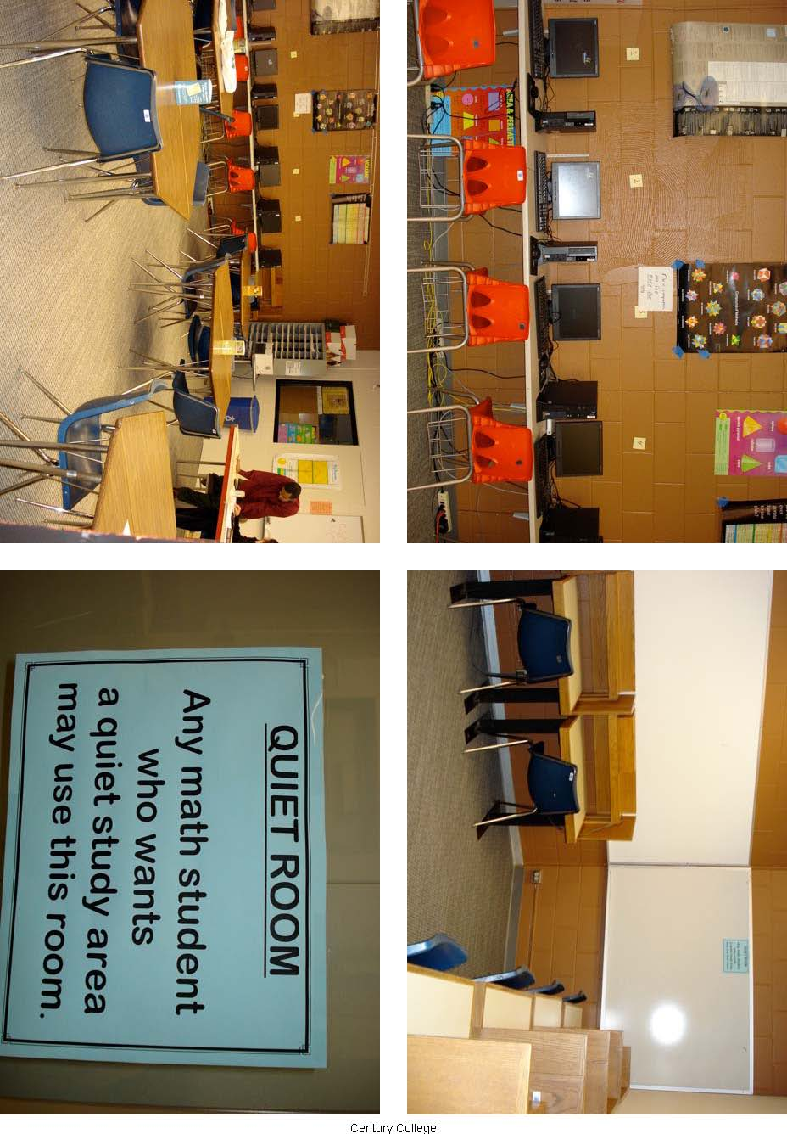
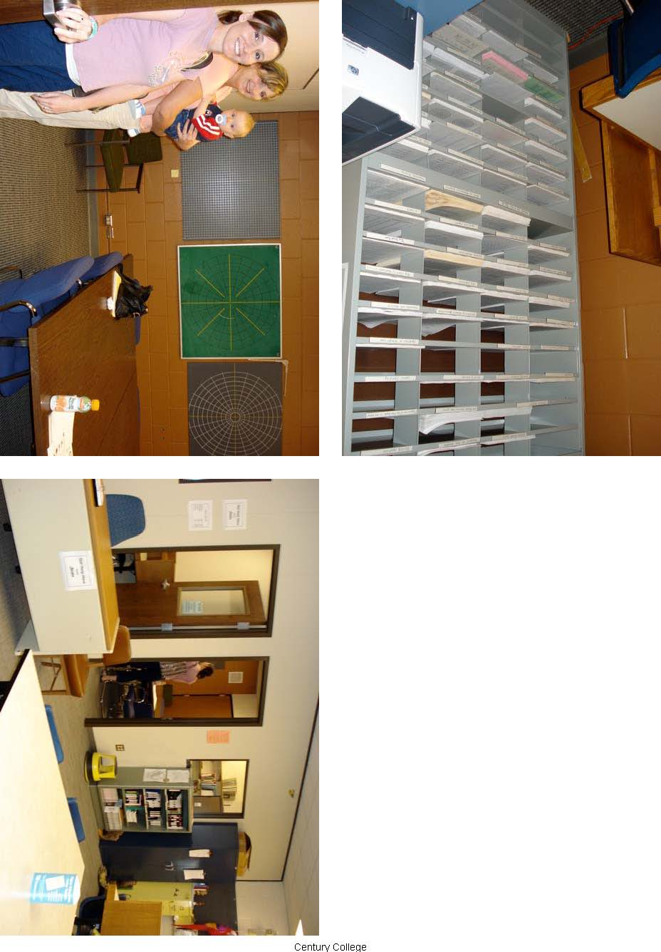
Christie’s Inver Hills MRC Visit

ARCC team: Dave, Nina, Christie

NHCC team: Jan

Questions to ask MRC’s
- What type of physical set up do you have? Connected to learning center or your own space?
VERY open. (a little bit too open??) They had a large space. Close to the (much smaller) tutoring center. Had their own large computer area.

- What is the focus of your MRC? Developmental, college-level, both?
Both. Jan guessed 50-60% developmental.

- What type of staffing do you use?
12 credits per semester (instructors). Jan has 4 credits per semester for administrative.

Do you have a CLA? What are their responsibilities? Who do they report to?
2 CLA’s, one had a BS in math (worked 30 hours), the other was a retired engineer (20 hours) Jan mentioned that the CLA’s spent much of their time walking around offering help, this was a different approach than most of the other schools had.

Do you use student tutors? How many?
No, but some of the peer tutors (from tutoring center) will fill in any “gaps”

- What hours is your MRC open? Nights? Weekends?
9-6 M-H
9-1 F

- What types of connection between the MRC and the classroom do you have?
They give instructors time in the MRC if they needed a few credits to get their 30 credit load.

- What type of technologies do you use? To what extent?
Have a beautiful computer lab, lots of computers. But it was a little bit removed from the MRC.
How many computers do you have?
17
What types of software do you have?
Derive, Converge, “Winning in Math”, MiniTab, MyMathLab, etc. (seemed like they had it all)

- What is your yearly budget?
Lots of $ in salary. $500 for stuff. Software comes from Math dept or IT. Jan mentioned Grant money a few times.

- How do you measure student success?
They don’t but they would like too.
How do you track student usage?
Computer sign in and out (she had some wonderful graphs…I think we need this)

- What types of resources do you have for
Students?
They had lots of stuff. Books, solutions manuals, instructors send class info (syllabus, office hours, schedule, etc)
Instructors?
Books, solutions manuals
Do you have manipulatives? Magazines? Etc?
They had a whole cabinet full of great stuff. I didn’t write down what was in there but I know I took a picture of it ☺
- Do you have any advice for us in setting up our MRC?
Quiet testing room
Computer system for check in
Separate entrance (there was no door to this MRC, it was just off of a hallway)
Have offices (and group rooms) close by

- What do you wish you had?
More group rooms
Separate quiet and not-quiet rooms
Get teachers to invite students (give tours, put it in their syllabus, etc)

OTHER NOTES I HAD
- Have vending machines near by
- Have headphones
- Scratch paper box
- Have name tags
- Jan also shared MANY handouts with us, I have
  - Average usage data
  - Student Evaluation forms
  - Percentage breakdown by class
  - Form for instructors (what are students allowed to use type)
  - Tutoring tips
  - MRC pamphlets
  - Other stuff

MY IMPRESSIONS
I liked the looks of this MRC but I can see where it could be problematic during the school year. It was VERY open!! Which is nice and inviting but Jan mentioned the noise a few times (there were no doors to the MRC). Jan seemed very organized. After looking at the graphs of student usage she had, I really think we need a computer sign in.
Summary of Visit to Inver Hills Community College
By Dave Roddy

This program was the most complete and extensive math resource center we visited to date. They had both a math resource center and a tutoring center for all subjects.

The math resource center required the students to sign in and sign out so that information as to the use could be shared with administration and instructors. Some of the math instructors used time in the center to give some minimal extra credit points. The math faculty was generally involved in support for the math resource center as some spent time there with individual students and groups as well. There were two tutors assigned to the math resource center which appeared to meet the needs of students seeking help.

There was a computer lab as part of the math resource center and several types of math software was installed and used by students as determined by their instructor. There was one ‘hybrid’ math course which used the computer lab as an integral part of the course. The math software used was built into the math budget.

The tutoring center was used by students who signed up for tutoring for the entire semester. They would come at the same time each week to work with the same tutor. This was used by all academic areas including math.

Positive Issues that could be utilized in Anoka Ramsey math resource centers.
- The use of computer sign in was used to determine use and future changes in math resource center.
- Math faculty were very much involved in the math resource center
- Use of computer lab for supplemental instruction appeared to be a positive part of this program
- The physical layout of the math resource center was attractive to students as there was sufficient space to accommodate a large number of students
- Students in all levels of math could receive tutoring
- The tutoring center was a unique idea on helping students through the entire semester.
Negative Issues which may not be appropriate for Anoka Ramsey math resource centers
- There were only two tutors assigned to the center and it was not clear if this was enough to help all students who need assistance.
- There was an extensive amount of math software which had been put onto the computers in the lab and it was not clear how much it was used

Final thoughts
This math resource center was very well run and included a director, 2 tutors, and faculty involvement. The monitoring of students via computer was used in an appropriate manner and this appears to be something that we would want to do as well. They had a lot of data and graphs to show how many students were using the math resource center. The physical layout was one of the best to utilize staff and accommodate students that we have seen so far. The tutoring center where students signed up for a semester was a very interesting idea which we may want to consider as well.

Visit to Inver Hills Community College - Nina
July 31, 2007
ARCC representatives – Nina, Christie, Dave
Inver Hills representatives – Jan Kamp, Math Center Coordinator and Math
Instructor, Cynthia Weishapple, Dean

- What type of physical set up do you have? Connected to learning center or your own space?
Located on top floor of library (actual library facility is downstairs), in open area adjacent to Peer Tutoring, surrounded by Faculty Offices. Writing Center, Testing Center are nearby. Math Center Computer area is also adjacent. There is a separate room shared with Peer Tutoring for small meetings (mostly for tutors, instructors, etc). Other rooms are available in the library for student study groups (but the rooms are very cold in the winter so don’t get much use). There is a locked cabinet with books, solutions manuals. Students must sign-out materials.

- What is the focus of your MRC? Developmental, college-level, both?
All levels. Estimated 50% developmental (that’s very impressive according to what we’ve heard from other MRC directors). Jan says the Math Center is really like a study hall but that lab assistants will answer questions. More intensive tutoring is provided by Peer Tutoring.

- What type of staffing do you use?
Two lab assistants. One has BA in Math, works 30 hours. Other has engineering degree, works 20 hours.

Do you have a CLA? What are their responsibilities? Who do they report to?
Jan gets 4 credits/semester for coordination of MRC, 2 credits/semester for other work in MRC. Lab assistants officially report to Assistant Dean but supervised on daily basis by Jan.

Do you use student tutors? How many?
Peer tutors occasionally help out.

- What hours is your MRC open? Nights? Weekends?
M – Th 9 a.m. to 6 p.m.
Fri 9 a.m. to 1 p.m.

- What types of connection between the MRC and the classroom do you have?
Some teachers give extra credit for using Math Center. Some classes assign computer work (typically 1 point for an hour and up to 2 points per week). Each instructor fills out forms for the Math Center staff giving guidelines for their classes. Some instructors may spend 1 credit of their time helping out in Math Center.

- What type of technologies do you use? To what extent?
Nice large computer area just for Math Center!
How many computers do you have?
I counted about 16.

What type of software do you have?
Derive, Converge, “Winning in Math”, Minitab, MyMathLab, “Lifetime Learning Library” (includes videos, lessons through intermediate algebra), other stuff.

- What is your yearly budget?
Budget covers mostly salaries.
$500 budget for other stuff. Licenses for software come from Math Dept. or Technology budget. Also receive grant money of various types.

How is it usually spent?

- How do you measure success?
No hard data. Formal student evaluations and tutor evaluations (I think Christie may have copies of these).

How do you track student usage?
Student sign-in in and out on a computer (enter ID, Math class). Lab assistants record how many students are using MRC each ½ hour. Jan has extensive statistical records of this info. (I think Christie got some of this too).

- What types of resources do you have for
Students?
Skill sheets, books, solutions manuals, etc.

Instructors?
Calculators, textbooks

Do you have manipulatives? Magazines? Etc?
There’s a whole cabinet full of cheap but good stuff!

- Do you have any advice for us in setting up our MRC?
Definitely have faculty offices close by.

When setting up your MRC did you use any outside help?

- What do you wish you had?
Jan is actually happy with the amount of faculty involvement she has and “pretty happy” in general with the way the Math Center works. Some things she would like to have:
  - “Differentiated areas” for group study, quiet areas, etc.
  - More group study rooms
  - Separate room for computer area
  - Ways to get students to use it more

What works for you?
Faculty put information about the Math Center in their syllabus. Students getting extra credit helps bring students in.

What doesn’t work for you?
Open design and location makes it a little too noisy with too many distractions.

My thoughts:
The Inver Hills Math Center comes closest to my ideal in terms of resources: computer sign-in, two lab assistants, large computer area, books, skill sheets, manipulatives, etc. I was not as impressed with the physical space as it was in a large open area with potential for much distraction and noise. Cynthia dropped by and seemed quite happy in her new job. She suggested we involve a research person (Brian?) in the project from the beginning to deal with compiling the numbers on usage and success rates that everyone will want. Cynthia took Jan and me to lunch (nyah, nyah!). We intensely discussed educational issues such as what was going on at Hogwarts School of Witchcraft and Wizardry (do they have a Math Center there – arithmancy maybe?).

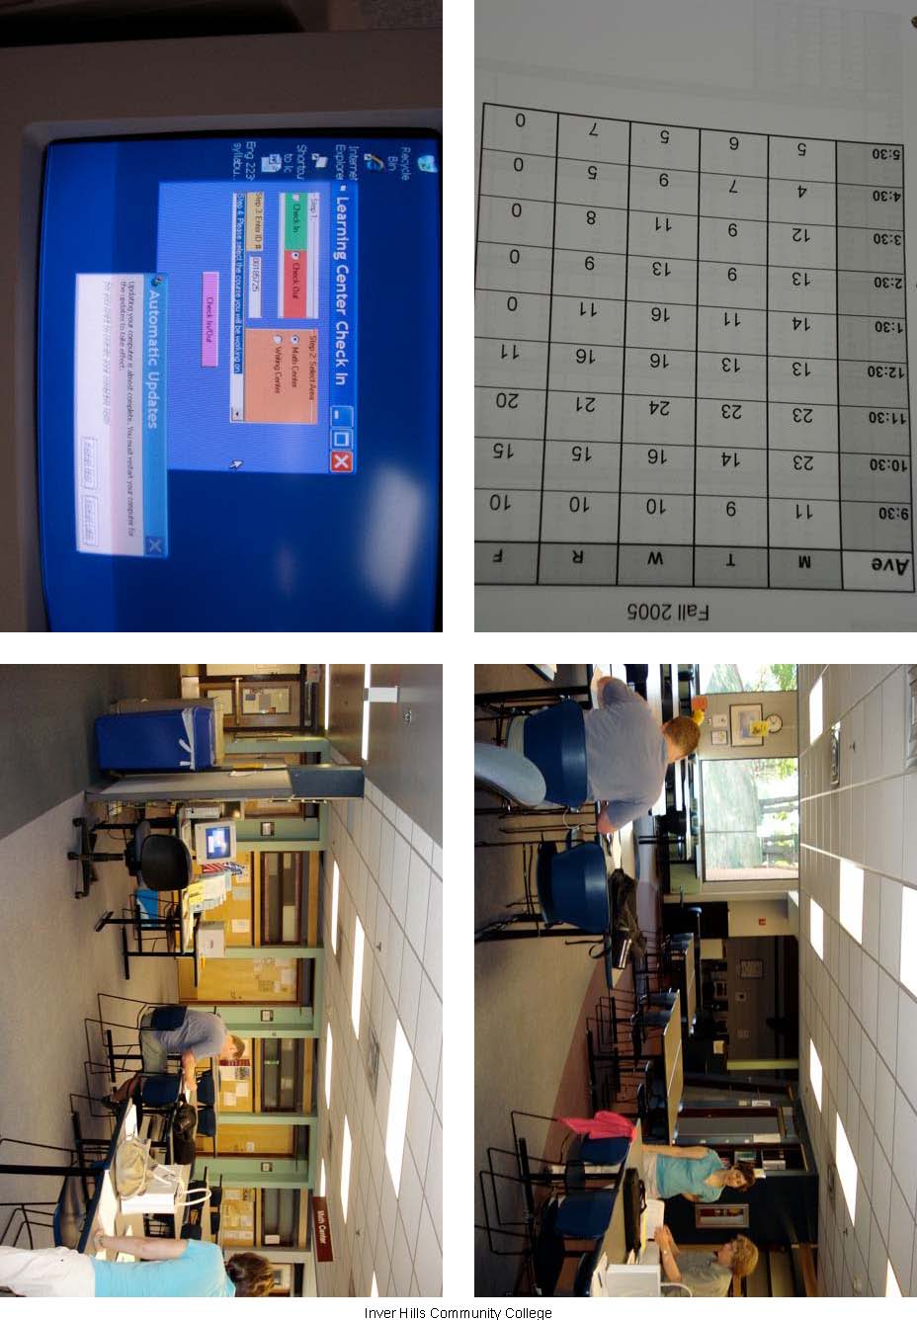

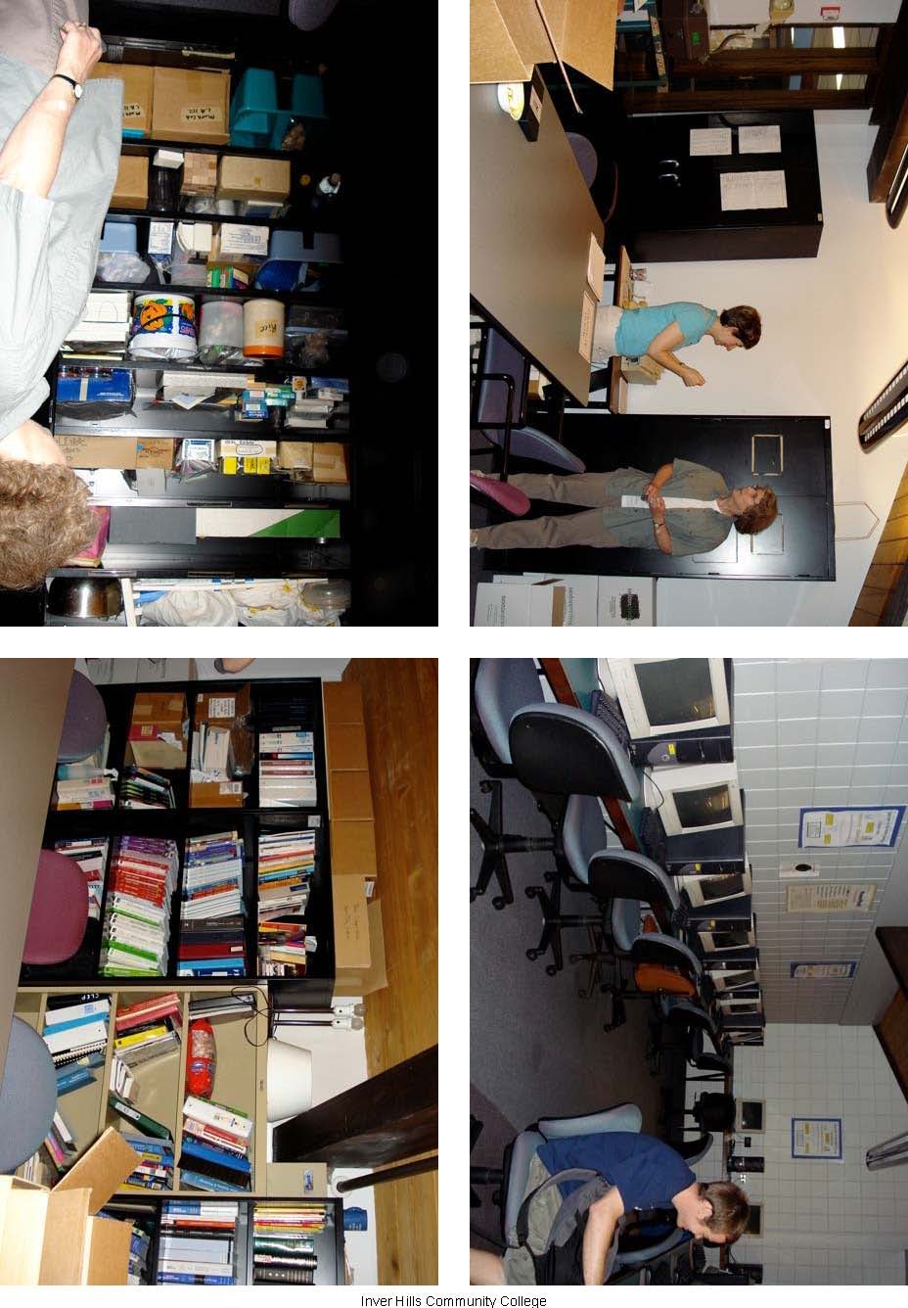
Christie’s NHCC MRC Visit

ARCC team: Dave, Nina, Sasha, Christie

NHCC team: Dale Bradtke, Joseph Crowe

Questions to ask MRC’s
- What type of physical set up do you have? Connected to learning center or your own space?
Attached to the Tutoring Center (which is inside the library). It is also next door to a computer lab with windows between the two rooms.

- What is the focus of your MRC? Developmental, college-level, both?
Both. Although some things are in the works for encouraging developmental students.

- Do you have a CLA? What are their responsibilities? Who do they report to?
Dale (CLA II but should be something more). Answer student questions and run the MRC. He also gives make-up tests and helps with computer software. (He also did a bunch of other stuff, such as getting textbooks and writing Accuplacer review books). They also have a part-time person that works at night.
Do you use student tutors? How many?
Yes but the student tutors spend most of their time in the Tutoring Center (I can’t remember what they called it???? They didn’t say Tutoring Center did they??)

- What hours is your MRC open? Nights? Weekends?
M-H 8:00-8:00
F 8:00-4:00
Sat 9:00-1:00

- What types of connection between the MRC and the classroom do you have?
Not much. They are trying to work out some more communication between MRC and faculty. Dale does always make sure to ask who the student’s instructor is.

- What type of technologies do you use? To what extent?
Dale knows most of the software that the faculty uses. They use the computer lab that is next door. They are thinking about adopting “Enable” which is an online developmental homework program (the ARCC group had never heard of this. Although when I was in high school they had the ENABL program which stood for Education Now And Babies Later. I didn’t mention this at the meeting.)

- What is your yearly budget?
$700
How is it usually spent?
Calculators, copies, etc

- How do you track student usage?
Track the number of questions answered each day. Dale answers between 400 and 500 questions per day!!! Sometimes he will track the type of questions being asked (maybe how many questions on fractions does he answer) and then he will plan a workshop on that topic. He kept track using a very well organized tally sheet.

- What types of resources do you have for
Students?
Videos/CDs/DVDs can be checked out overnight (they have at least two copies of them all)
Textbooks (old versions of instructor’s edition)
Student copies that students can use in the MRC
Some student solution manuals (to be used in MRC)
Worksheets

Instructors?
I didn’t see any.

Do you have manipulatives? Magazines? Etc?
No

- What do you wish you had?
More faculty involvement (I’m starting to notice a theme here)
Many options for student learning (audio, visual, hand-on, computer-based)
More student tutors

OTHER NOTES I HAD
- MRC is all drop-in help
- Dale/Joe promote faculty holding office hours in MRC
- They mentioned that it is tough to find (and keep) a CLA. When looking for a person they recommended someone with a background in Math but with some teaching experience
- They hold workshops on all sorts of things (ex. Test-taking, math anxiety, etc.)
- Joe said “ASC is sit down, the MRC is fast food”
- I left with a flier (with location, hours, etc) and a bookmark type thing (with same info)

MY IMPRESSIONS
This MRC had a nice, cozy feel to it. I liked the space they had. It was smaller than both Stout and Century but they made it work with the extra space in the Tutoring Center (right outside the door). I also noticed that they had windows similar to Century’s (so that you could see into the MRC before you walked through the door).

Dale had an awful lot of responsibilities! Dale had a great personality for his position, he was very easy to talk to. At this point I am fairly certain that we need to find a wonderful person to head up the MRC.

It seems like everywhere we go they talk about the importance of faculty involvement. I’m really hoping that our faculty jump on board with the “hold one office hour a week in the MRC” idea.
Summary of Visit to North Hennepin Community College
By Dave Roddy

This visit included looking at both a math resource center and a tutoring center for all subjects including math.

In the tutoring center, students signed up via computer and were assigned or found a tutor which they could work with for a short period time or up to about one hour. The tutors in this setting were students and they also would work with groups of students. There were math tutors for all levels of math and the area was quite large to accommodate all subject areas.

The math resource center appeared to be one large office with some tables run by the director who did the tutoring. This was supposed to be used by students on a walk in basis and was for getting questions answered and help for a short period of time (5 to 10 minutes). The tutor handled math as well as chemistry and a few other subjects.

There was a computer lab which was used by students for supplemental instruction but only if assigned by their instructor. There did not appear to be much coordination or support from math faculty in either center.

Positive Issues that could be utilized in Anoka Ramsey math resource centers.
- Sign in via computer to keep track of student use of tutoring center
- Identification of tutors and their expertise
- A specific math resource center

Negative Issues which may not be appropriate for Anoka Ramsey math resource centers
- One person, the director did all the tutoring in math resource center
- Math faculty were not involved in much of the math resource center operation.

Final thoughts
My first impression is that the math resource center was operational around one person, the director. There was also not much interaction between math resource center and math faculty. I did think that they did meet the needs of most students who came for math help. The tutoring center made very good use of staff and facilities for helping students. They also had printed information as to the rules for use of the math resource center and tutoring center which made it more attractive to students and easier to use. They had bios of their math tutors posted which helped students find the correct one for their questions. In general, this was a very well run program.
Visit to North Hennepin Community College - Nina
July 17, 2007
ARCC representatives – Nina, Sasha, Christie, Dave
NHCC representatives – Dale Bradtke, MRC Supervisor, Joe Crowe, Tutoring Center
Director

- What type of physical set up do you have? Connected to learning center or your own space?
Separate room located in the library. Adjacent to Tutoring Center (an area of open space in the library). MRC room was rather small but cozy with round tables, chairs, couch, coffee table, lots of bookshelves. Also adjacent to computer lab (sometimes used for a place to put students who are testing). There was a very small area cordoned off by bookshelves for watching VHS tapes or for “quiet” space. Supervisor had desk.

- What is the focus of your MRC? Developmental, college-level, both?
All levels. There is something called “First Year Experience” program that targets developmental students but not sure of the details. Dale tries to encourage study groups (used mostly by higher level students).

- What type of staffing do you use?
Dale is pretty much it. He has many years experience, degrees in math and science. Helps everybody and anybody, including students in other disciplines and students from outside the college. Successful operation of this MRC really depends on Dale. “There is pretty much always a line for help.”

Do you have a CLA? What are their responsibilities? Who do they report to?
I think Dale is CLA2 but is expecting to be (should be) promoted to Director. Reports to Dean of Math and Science.

Do you use student tutors? How many?
Student tutors in adjacent Peer Learning Center but none in MRC.

- What hours is your MRC open? Nights? Weekends?
M – Th 8 a.m. to 8 p.m. (part-time person staffs at night)
Fri 8 a.m. to 4 p.m.
Sat 9 a.m. to 1 p.m. (mostly students preparing for tests)

- What types of connection between the MRC and the classroom do you have?
Nothing formal. When Dale was asked if faculty members spent office hours in MRC, he replied, “Heck no!”

- What type of technologies do you use? To what extent?
Adjacent to computer lab.

How many computers do you have?
What type of software do you have?
Didn’t get this info.

- What is your yearly budget?
$700/year for calculators, duplicating, etc. Textbooks mostly supplied free from vendors.

How is it usually spent?
Very quickly.

- How do you measure success?
Don’t track students, only questions asked. Answers 400-500 questions per day. May implement student tracking in future.

How do you track student usage?

- What types of resources do you have for
Students?
Older textbooks (current textbooks are behind desk), some solution manuals, video tapes from older textbooks, skill sheets. Students can use calculators for 2 hours if leave driver’s license. (Students can rent calculators from Math secretary).

Instructors?

Do you have manipulatives? Magazines? Etc?

- Do you have any advice for us in setting up our MRC?
Dale thinks we are going to have a difficult time finding someone to staff our MRC. He says we should get at least a CLA-2. Need BA Math, teaching experience, online experience, etc.

When setting up your MRC did you use any outside help?

- What do you wish you had?
  - Faculty involvement and support (faculty should let CLA know what text they are using, what they are doing in class, etc.)
  - As many options as possible for student learning
  - Tutorial software (such as MyMathLab) – students would love this
  - More money
  - Student tutors
  - More space

What works for you?

What doesn’t work for you?

My thoughts:
I didn’t like too much that the MRC was in the library (math faculty offices are in another building). The space seemed rather small but cozy (I liked the couch and coffee table). Again, there were windows into the room from the library. Dale is a gem (we tried to lure him to ARCC but I think we’d need big bucks and a big title to do so). The place pretty much falls apart when he is away. We should make sure we have several people who can provide back-up if the CLA in not available for some reason.

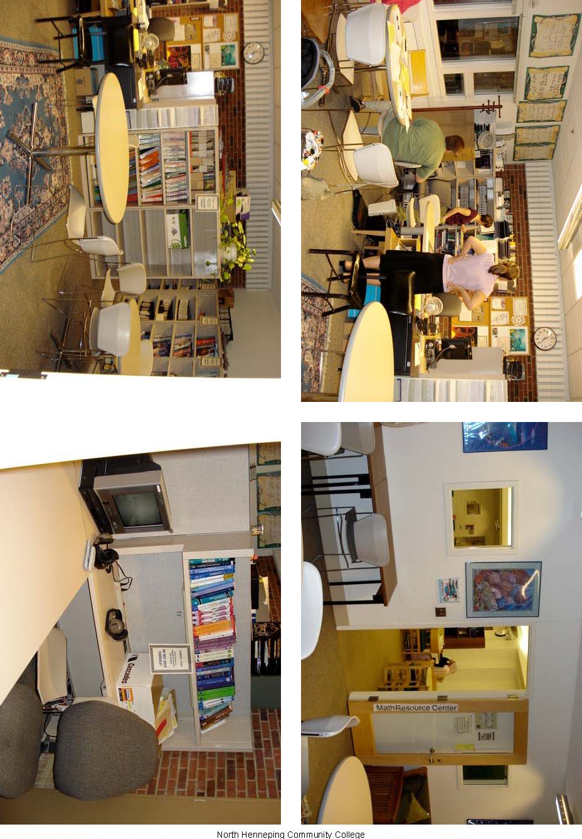

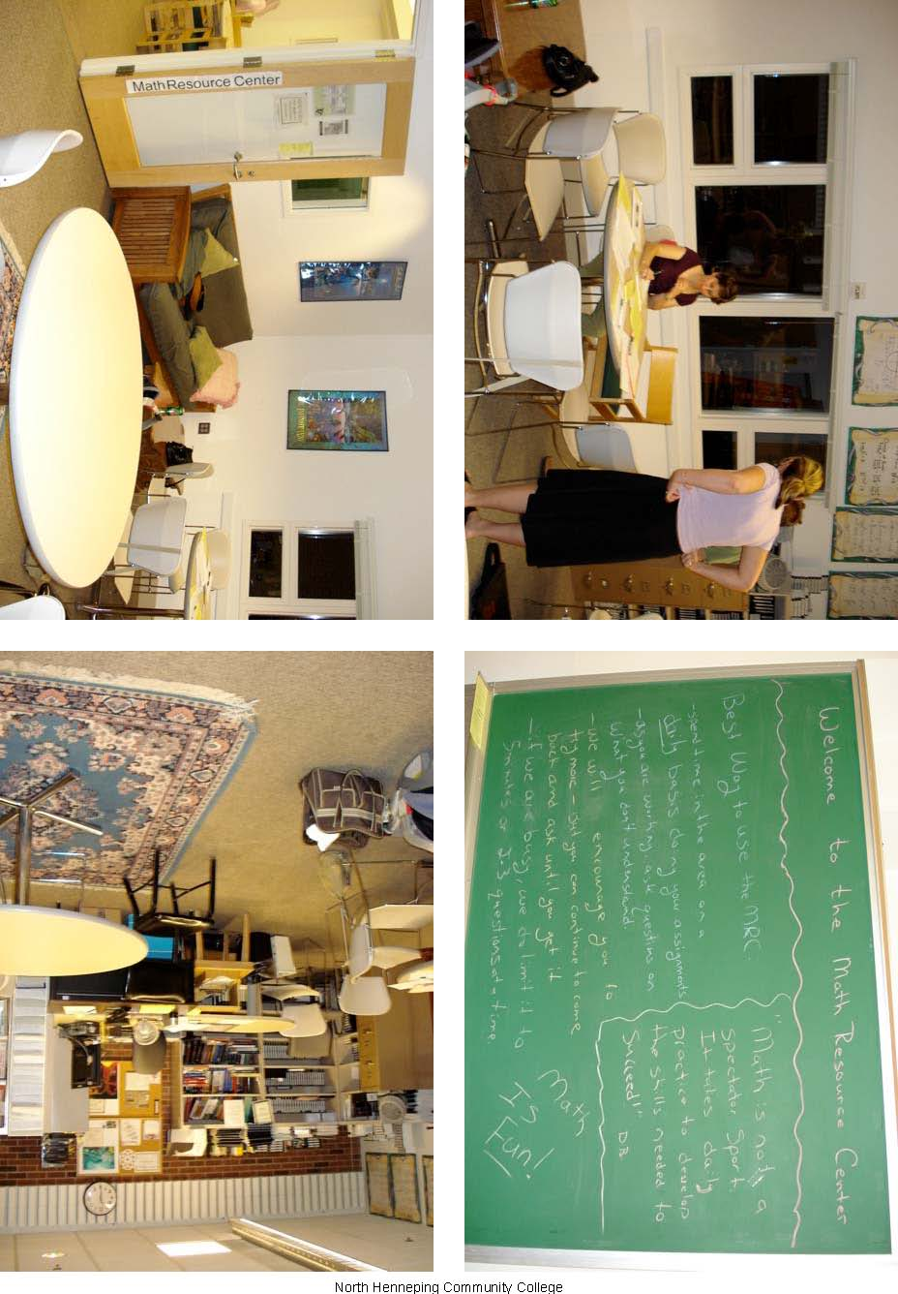

Christie’s Normandale MRC Visit

ARCC team: Dave, Sasha, Christie

NHCC team: I didn’t write down his name but he was very friendly ☺

Questions to ask MRC’s
- What type of physical set up do you have? Connected to learning center or your own space?
Own large space, with computers off to one side (kind of around a corner). A separate testing room (40-45 students) but it was attached with windows in between. I would LOVE a setup like they had!

- What is the focus of your MRC? Developmental, college-level, both?
Solely Beginning Algebra and Intermediate Algebra. They held these classes in this space. It was a mix of MRC and classroom.

- What type of staffing do you use?
3 full-time CLA’s and 1 part-time to fill-in schedule
Faculty are in MRC during their class time.
Do you have a CLA? What are their responsibilities? Who do they report to?

Do you use student tutors? How many?
50-55 hours per week, 1 at a time, about 10 per semester

- What hours is your MRC open? Nights? Weekends?
60 hours/week (I didn’t get the exact hours)

- What types of connection between the MRC and the classroom do you have?
Extensive. The classes were held in the MRC (no outside lecture) students worked at their own pace (but were held to exam deadlines), took exams in the testing center. No scheduled time that students had to be there but will be switching fall semester to scheduled time in the MRC/class.

- What type of technologies do you use? To what extent?
Lots of the class material is online (book, quizzes, homework, etc) but it is optional for the students.
How many computers do you have?
About 29
What types of software do you have?
MyMathLab and MathXL

- What is your yearly budget?
Wasn’t sure but he said that IT took care of the computers.

- How do you measure student success?
Since this is their classroom they can look at grades and drop-out rates. (About 40% success)
How do you track student usage?
2500 students/year
- What types of resources do you have for
Students?
Computer/online is their biggest resource. About 25% do everything they can on the computer. 10-15% don’t use it at all.
Instructors?
Since they hold their classes in MRC, they have tutors and CLAs available
Do you have manipulatives? Magazines? Etc?
no
- Do you have any advice for us in setting up our MRC?

- What do you wish you had?
More space for “formal” class. i.e. a classroom

OTHER NOTES I HAD
30-35 sections in MRC, 10 sections in traditional classroom
They are willing to send us their MyMathLab stuff
They are also very good at transferring stuff from MyMathLab into D2L
Common text->Bittinger-Beecher

Tutoring Center
We also visited their tutoring center, here are the notes I had:
About 20 tutors, most do math but also do other subjects
Walk-in only
Some faculty spend 1 office hour / week there
Some retirees volunteer their time (great community involvement ☺)
Visit classes the first week
Spring semester had about 1700 students total, about 1041 math
Also have a one-on-one program (grant funded and is available to very few students)
Will be using “The Master Tutor” book for their tutor training
Communication with facutly is VERY important
Faculty sometimes volunteer tutor
Have “Group Tutoring Room”
Include center in the orientation tour, said “Getting the students through the door for the first time is the toughest”
Don’t have enough space, often people waiting
Have pics of tutors and name tags (with classes they tutor)
Wish they had computer tracking

MY IMPRESSIONS
The actual MRC was setup more like Stouts. It was tide directly to the developmental courses and was NOT designed as a general study center. To be honest, I’m surprised the set up worked for most of their students. It was very self-paced, students didn’t have ANY scheduled class time, they simply came to the center whenever they wanted to work on the material and learn it on their own. They had a wonderful physical space for what I envision our MRC to be; a ‘testing room’ that could be used for quiet study, a large and inviting main room with the computers in the same room yet somewhat separated, they had large windows looking in from the hallway. The only thing they were missing was a group study room. Even though they had the furniture pushed to one side (I’m guessing they were cleaning over the break) it looked like a beautiful space.

The tutoring center’s program was more of what I think we are going for. They had walk-in tutoring (but for all subjects). The tutoring center was more closed off. I liked the idea of having volunteer tutors from the community come in. They also seemed to be more involved with the faculty.
Summary of Visit to Normandale Community College
By Dave Roddy

The first visit was to the math resource center which is used primarily for the developmental math courses. There are two types of developmental courses. One is based in the math resource center where students come every day to do their homework and take progress quizzes and chapter tests. There is no lecture and students go at their own pace. There are benchmarks as to when students must complete chapter tests and if a student does not make this benchmark they often drop out of the class.

The math resource center has a large computer lab where students can take quizzes and tests. There are also paper versions which they may choose to take instead of by computer. During the class hours the instructor circulates around and helps students with assignments and occasionally some take a small group into a classroom to explain a math concept. Since all quizzes and tests are computerized, the instructor has up to date information on the progress of all of their students. There are also a couple of student tutors to assist students. Students may sit in on any lectures given to those students who chose a lecture based approach rather than independent study through the math resource center

The other option for instruction is to take the developmental math courses via lecture and use the math resource center for quizzes and tests.

The second visit was to the tutoring center which was used to tutor all subject areas including upper level math above the developmental courses. Students would sign in on paper and then seek out a student tutor in the specific subject/course. Tutors sat at a table with a sign to indicate their area of expertise to help students quickly find the appropriate tutor. There is a training session for student tutors at the beginning of the school year that tutors must attend. Also, some people from the community who were retired donated some time to assist tutoring in the center.

Positive Issues that could be utilized in Anoka Ramsey math resource centers.
- The use of computers to give quizzes and tests would allow instructors to devote more time to instruction.
- The use of people from the community would be a positive influence on the college as it would provide extra tutoring service but also help create a link between the community and the college.
- The tutoring center was partially financed by community organizations such as Rotary.
- There was positive instructor interaction at both the math resource center and the instructional tutoring center.

Negative Issues which may not be appropriate for Anoka Ramsey math resource centers
- The most negative fact was that their success rate was between 40-50%. It was not clear if this rate was for both math resource based classes and lecture based.
- There was a lot of drop outs when students could not make bench mark dates for tests.
- Students in the math resource center based courses could attend lectures by other instructors but if they were not at the same point in the textbook then the lectures would be inappropriate.

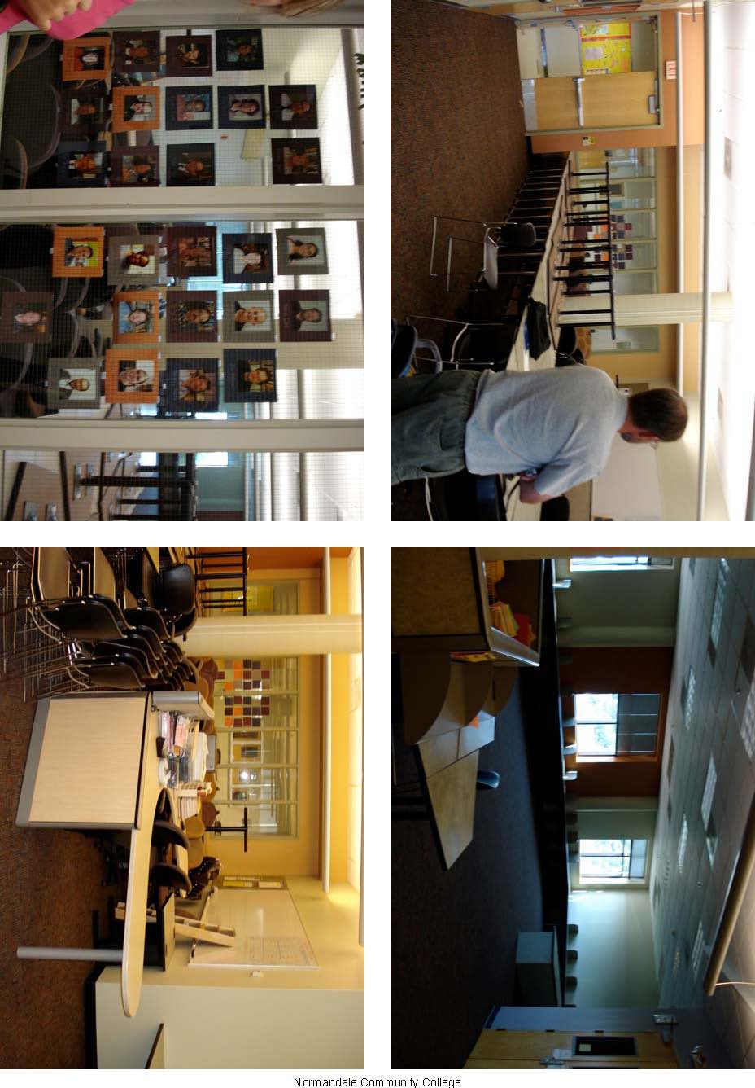

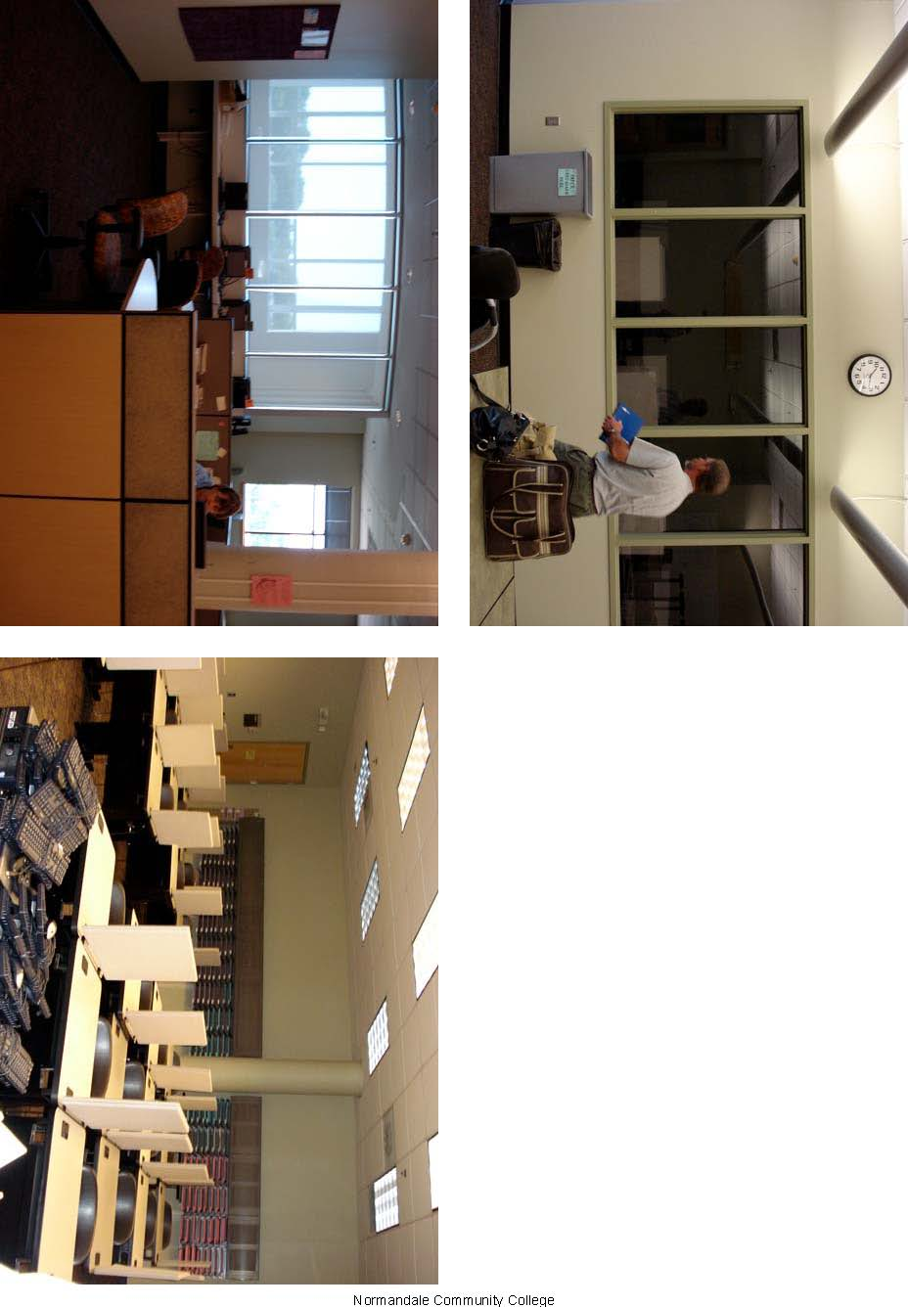
Christie’s UW Stout MRC Visit

ARCC team: Dave, Nina, Sasha, Barb, Christie

Stout team: Jean Foley, Deb Sins, Ilene Zito, Debbie Crushal (Dean John Murphy stopped by)

The Stout team calls their MRC a Math Teaching and Learning Center (TLC). I will refer to it as an MRC because I am not smart enough to keep switching back and forth between all of the different names ☺

Questions to ask MRC’s
- What type of physical set up do you have? Connected to learning center or your own space?
Classroom next to study center (extra overflow room next door)

- What is the focus of your MRC? Developmental, college-level, both?
Focus was solely developmental. There was another center for college-level

- What type of staffing do you use?
Students (some TA’s) and faculty
Half time director
Project coordinator -> full-time math dept faculty (release time???)
Faculty teach the courses
1-3 people in the MRC at a time
Student tutors come from faculty recommendations
Jean meets with the tutors every other week for 1.5 hours. She makes them work the homework problems and they must know the software used with the courses.

- What types of connection between the MRC and the classroom do you have?
The MRC is linked directly with their developmental classes. (This is a gross understatement)

- What type of technologies do you use? To what extent?
LOTS of online/computer stuff. Homework, quizzes, and textbooks were all online (I believe the online textbook was optional). Stout used MyMathLab as it’s online thing. It’s very important to note that Stout is a laptop campus, so each “desk” was equipped with an internet jack and outlet but no computers.

- What is your yearly budget?
I didn’t write down how much their yearly budget was…did anyone else get this?
Two major expenses for them are salaries (director and about $16,000 for tutors) and software. Much of their budget came from a “Student Access to Learning Fee” which was built into student tuition.

- How do you measure success?
There is a report on their website (www.mathtlc.uwstout.edu) detailing their success (and they have had much of it!!)

How do you track student usage?
They have a paper form/sign-in sheet but they would like to move to a computer based sign in.

- What types of resources do you have for
Students?
I noticed that they did not have much in terms of resources. Pretty much it was just a classroom and a room with some desks.

Instructors?
I didn’t see anything.

Do you have manipulatives? Magazines? Etc?
NO

OTHER NOTES I HAD
Dean John Murphy made many wonderful points, SOME of them were
- The MRC is a huge help to minority students, specifically he mentioned women and non-traditional students (the data is in the report on the website).
- Administratively, the MRC is very cost effective.
- He gave us a report titled “Chancellor’s Enrollment Task Force” which I have not looked through yet (but I intend to soon)

The Stout team feel that having faculty members hold some office hours in the MRC was VERY helpful. It helped the students to realize that the faculty are approachable (well, at least some of the faculty are approachable).

One thing I really liked was their “Bios” hanging on the walls. They had pictures of the faculty and tutors hanging on the walls with a short paragraph about each person (both their math background and some personal information). It added a nice feel to the room and also gave students a chance to get to know some of the people working in the MRC. I also noticed that they had nametags for the faculty/tutors, I am terrible with names so I would like the friendly reminder of who is who.

They Stout team will have some more information gathered for their July workshop. If we contact them after the week of July 23 they will send us some CD/online information.

MY IMPRESSIONS
The Stout team has a wonderful set up but it is not quite what I had in mind for our MRC, for a couple of reasons. First, the focus of their MRC is solely developmental and I would like to see a MRC where students are welcomed at any level (possibly even get some students that “move up” through the math classes using the MRC all the way. Secondly, having the MRC so tied to the classroom lessened the instructor’s freedoms (things like choosing textbooks, homework assignments, and/or online tools).

I noticed that they did not have a huge space designated to their MRC. The classroom was a normal sized classroom and the study center part was even smaller. I didn’t care for the way they had the study center room set up, the desks were all facing the walls and there was no place for group work.

Summary of Visit to Stout
By Dave Roddy

The math resource center was used primarily for developmental math courses but were also available to students in the upper level courses. There was an integration of use of the math resource center by the developmental courses which also included required use of laptop computers to complete daily assignments and take quizzes and tests.

As students all receive a laptop as a freshman, all of the student work was monitored on the computer. The instructors still did their ‘lecture’ but this was followed by a period of time where the students did assignments and entered their answers on the computer. Instructors had continuous access as to the level of completion of those assignments and the accuracy of the work.

There was evidence of improvement of student success within those developmental courses but it was not clear if this translated into more success in the upper level math courses.

It appears that the main reason for the success of students is accountability. They are continually monitored via computer.

Positive Issues that could be utilized in Anoka Ramsey math resource centers.
- Use of computers for supplemental instruction
- Use of computers to monitor student progress

Negative Issues which may not be appropriate for Anoka Ramsey math resource centers
- Monitoring of all homework via computer as ARC students do all have laptops like Stout students.
- All instructors use the same text so common software can be used
- Stouts program is primarily for developmental math

Final thoughts
This program and its results are impressive, but I do not see a great deal of application to our math resource centers.
Math Resource Center Project - Nina
Visit to University of Wisconsin, Stout
July 10, 2007

Notes and Summary Report
Nina Bohrod

The ARCC contingent consisted of Barb, Sasha, Christie, Dave, and me. Dave drove the state vehicle and wished the topic of conversation would change from “best baby-nursing practices” to “best teaching practices” or at least “How ‘bout them Twins?”. The Stout team (and I make no aspersions on their individual or collective weight by referring to them as such) consisted of Jean Foley, Deb, Eileen, Debbie (sorry, didn’t get the last names), and John Murphy from the Dean’s office. Jean is the director of their “Teaching and Learning Center” (is that what they called it?) and is also a faculty member. Deb, Eileen, and Debbie are Math Faculty members.

My first impression on entering the TLC was that the physical space was not overly large. There were two rooms. The first was a typical-size classroom with tables and chairs. There was a computer projector and screen and white board up front. The tables had connections for students’ laptops (U. of W. Stout is a laptop campus). Decorations were scarce but there was a bulletin board with photos and short biographies of faculty and tutors (a friendly touch).

The second room was the tutoring center. It was a fairly small room and had student desks and chairs along the wall. There was a typical office desk in the front where students signed in to the room and where the tutor sat (I guess). More bios decorated the walls. There was a noticeable lack of resources such a reference texts, worksheets, software, manipulatives, etc.

The Stout team was a friendly and enthusiastic bunch. There is no doubt that their set-up has enjoyed much success. They have a lot of statistics to back them up but the only one I wrote down was that their developmental math students have gone from a 33% to 10% failure rate.

John provided us with a report on retention (“Chancellor’s Enrollment Task Force”) in which the most relevant and important point for this project are as follows:
- One of the most important factors affecting returning student retention is whether the student takes and passes a math course in his/her first semester.
- Having a “higher” ACT math score is also a significant predictor (U. of W. Stout looks for an ACT score of 21 or higher for preference in admission).

I didn’t get much information on funding but John stressed that the TLC program is “cost-effective”. Tuition includes a fee which provides much of the funding for TA’s and software for the program.

Here’s basically how the Stout TLC program works (I didn’t take a lot of notes so I’m counting on the rest of you to fill in some of the details I missed):
The TLC focused on students in Beginning and Intermediate Algebra. All sections for those classes are taught in the TLC classroom (Intermediate Algebra classes are also taught online in the summer). Faculty all use the same textbook. Students complete all homework, quizzes, and exams using the MyMathLab software from Prentice-Hall publishers. Problems are conceptually consistent but number values are regenerated so that students cannot copy answers. Assignments are automatically graded by the software but, for quizzes and exams, students are required to show their work and instructors will review it and can provide “partial credit” if appropriate. In a typical class, a short lecture is followed by students working on their homework assignments on their laptops. Students are encouraged to work together with the help of the instructor and a tutor. Attendance is required and graded. The tutoring center is open for help outside of the classroom (I didn’t get the hours) and is staffed by trained teaching assistants. Faculty also dedicate a part of their office hours to help in the tutoring center.

Good stuff that we might want (or need) to use in our MRC:
- Small physical space.
- Trained tutors.
- Dedicated faculty.
- Friendly surroundings (faculty and tutor bios were a nice touch).
- Increased use and availability of software in classes and resource center.
- Funding through student fees?
- MRC website.
- Free promotional pens!

Stuff that might not work for us:
- Department-selected textbook.
- Laptop use in classrooms.
- Developmental-level exclusivity.

That’s all I can think of right now.

Note: U. of W. Stout TLC website: www.mathtlc.uwstout.edu

